METEOROLOGY 110 01 Fall, 2014

Exam #2 Name _____________________________________

This exam consists of 41 multiple choice questions worth 2% each and extended questions worth a total of 18%. Answer all multiple choice questions on the answer sheet by blackening in the correct space. Choose the one BEST answer to each question. READ EACH QUESTION CAREFULLY AND COMPLETELY! Answer the extended questions at the end in the table provided. You have 50 minutes. Check your answers

Questions 1-7 refer to the station plotted below



1. What is wrong with this station's observation?

a) The surface wind is 55 mph.

b) It is raining, but the temperature and dew point are not equal.

c) It is raining but the sky cover is 0 octas

d) The pressure isn’t low enough.

e) Nothing is wrong; all observations are correct.

2. The wind direction is from the:

a) north b) south c) east d) west e) calm.

3. The wind speed is

a) 43 mph b) 2 mph c) 10 mph d) 99.4 mph e) 15 mph

4. The pressure is:

a) 999.4 mb b) 994 mb c) 943 mb d) 1099.4 mb e) 1944 mb

5. The present weather is:

a) drizzle b) heavy snow c) fog d) steady rain e) none, no precipitation has been observed

6. If this is Oneonta in the Fall, an air mass which has the characteristics shown by this station's observations is:

a) mT b) mP c) cT d) cA e) cP

7. If you were on campus observing this weather, you might explain the wind by saying

a) Wind is flowing downhill to the river.

b) The buildings are channeling the wind between them.

c) A cold High is right on top of us.

d) A cold front is approaching from the west.

e) The Coriolis Force is turning a wind from the south.

8. The force which causes wind speeds to decrease is

a) the Coriolis force b) the Pressure gradient force c) gravity d) friction e) temperature

9. Pressure Gradient Force always acts in which direction?

a) from high to low pressure

b) from low to high pressure

c) toward the north

d) toward the south

e) toward the equator in both hemispheres

10. Coriolis Force always acts in which direction?

a) from high to low pressure

b) from low to high pressure

c) to the right of the wind in the Northern Hemisphere

d) to the right of the wind in the Southern Hemisphere

e) opposite to the direction of the wind in the jet stream

11. If you were flying from Montreal in Canada to New York City in the U.S., which direction would you have to fly to actually get there? (this is not a trick question. Consider the Coriolis Force. You can find Montreal and New York on the map on the next page)

a) south b) west c) southwest d) southeast d) east

12. On the radar map below, showers and thundershowers are moving from south to north while the line of echoes moves very slowly towards the east. Cities within the line get one echo after another. What is this phenomenon called by meteorologists?

a) Raining cats and dogs b) Slow-cooked c) City effect d) a souther e) Training

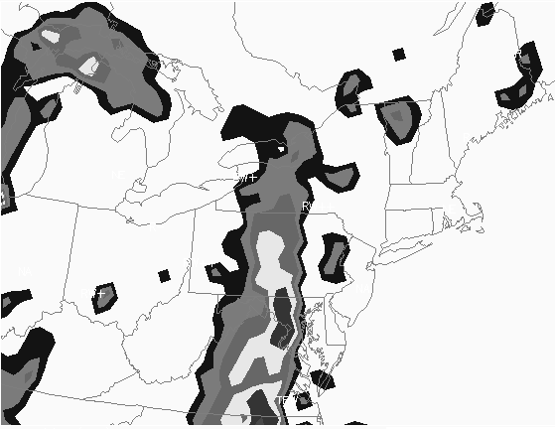

13. On the map above there are no echoes over the Atlantic Ocean. Why?

a) There are no clouds over the ocean.

b) On this day there is no precipitation over the ocean.

c) Radar does not work over any water body.

d) There are no radar stations out in the ocean.

e) The polar-orbiting satellite can’t see out over the Atlantic Ocean.

14. Name a weather map feature that could produce a line of thunderstorms such as the one on the map above.

a) cold front b) warm front c) Low pressure center d) High pressure center e) Lake effect

Questions 15-23 refer to the following weather map. Stations A, B, C, D, and E represent places in the U.S. and Canada. H and L represent centers of High and Low pressure

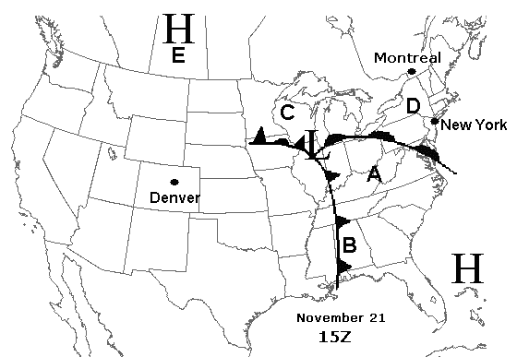

15. At which city is the temperature probably the coldest?

a) A b) B c) C d) D e) E

16. Assuming there is snow someplace on this map, where is it most likely to be snowing?

a) A and B b) B and E c) C and D d) only B e) only E

17. What type of precipitation is likeliest at B?

a) thunderstorms b) snow c) drizzle d) steady rain e) no precipitation

18. What type of precipitation is likeliest at station E?

a) thunderstorms b) heavy snow c) drizzle d) fog e) no precipitation

19. The big “H” means

a) Hot b) Heavy weather c) the center of High pressure d) all Hell is breaking loose

20. What kind of vertical motion is taking place at point B?

a) vigorous b) gentle c) downward d) no vertical motion takes place

21. What fronts are shown on this map?

a) stationary front and cold front b) cold front, warm front and occluded front

c) cold front and warm front d) cold front, stationary front, and warm front

22. At point C, the PGF is directed toward the

a) northwest b) southeast c) west d) city of Montreal e) city of Denver, CO

23. The wind near the Low is blowing most nearly

a) directly out from the center of the Low

b) directly into the center of the Low

c) counter-clockwise and spiraling into the Low

d) clockwise and spiraling out of the Low

24. 15Z is equivalent to what time in Eastern Standard Time (EST)?

a) 11 p.m. b) 10 a.m. c) 7 a.m. d) 7 p.m. e) 3 p.m.

25. The Bergeron process tells us something important about our mid-latitude weather. What is it?

a) Rain can fall at all times of year.

b) Fronts cause all our current weather.

c) In order for clouds to form, the RH must be 100% and there must be downward motion.

d) Coriolis Force and Pressure Gradient Force are equal and opposite.

e) All precipitation in mid-latitudes starts as snow.

26. It’s difficult to get many water molecules to condense in the same spot to form raindrops so they condense on a speck of dust or sea salt suspended in the air. These are called

a) condensation nuclei b) condensing molecules c) sublimation spots d) snowflakes

27. Rain falls out of a cloud but hits a road that is at 29ºF. What type of precipitation is that?

a) Rain b) Fog c) Heavy d) Snow e) Freezing rain

28. The region of the U.S. with the most thunderstorms on average over the course of a year is

a) the equator b) the Southeast c) the Northeast d) California e) thunderland

29. The thunderstorm's upper part (the part which spreads out) is called:

a) the updraft b) a rain accumulation c) a tornado d) the mean e) the anvil

30. The most dangerous and damaging tornadoes are rated:

a) EF1 b) EF2 c) EF3 d) EF4 e) EF5

31. Most deaths from tornadoes occur in:

a) the bathroom b) mobile homes c) phone booths d) shopping centers e) open fields.

32. On a weather map, steady, heavy rain would be shown as

a)  b)  c)  d)  e) 

33. The part of a lightning stroke which carries the most charge is the:

a) dart leader b) stepped leader c) return stroke d) electron stroke e) feint stroke

34. You are outside when the sky gets darker and you hear thunder. Your hair is standing on end. What is happening?

a) You are scared of the thunder b) Your hair needs washing

c) You are channeling a positive streamer d) You have been hit by lightning. You are dead.

35. Where in the U.S. are the most lightning strokes and the most lightning fatalities annually?

a) Florida b) New York c) California d) Texas e) Hawaii

36. It’s a warm and humid day. You see a thunderstorm coming. Suddenly the air gets much colder and the wind direction changes drastically. It’s blowing in your face. What do meteorologists call this?

a) a gust front b) the cold front c) the jet stream d) a wind front e) none of the above

Questions 37 - 41 refer to the following 300 mb upper air map. There are no stations but there are locations A, B, C, D, and E. Wind flags use the same format as we learned in lab 5 (campus observations).

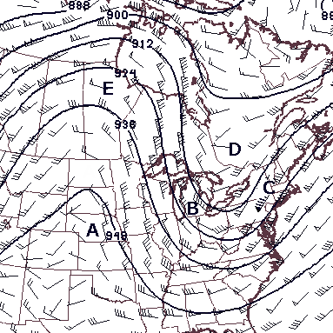

37. The upper air feature at location D is called a

a) trough b) ridge c) Low d) High e) Dragon

38. The wind at location C (Poughkeepsie, NY) is

a) 200 mph b) 35 mph c) 10 mph d) 85 mph e) 150 mph

39. The wind direction at location C is

a) northeast b) southwest c) calm d) overcast e) into the Low

40. The location which is most likely to be over a warm air mass at the Earth’s surface is

a) A b) B c) C d) D e) E

41. What is the most likely air mass under the feature at point D?

a) mT b) cT c) mA d) cA e) pT

Extended Question

For this question, refer to the following surface weather map. This is a “prog” which is a forecast map. Assume it is winter in the Northern Hemisphere.

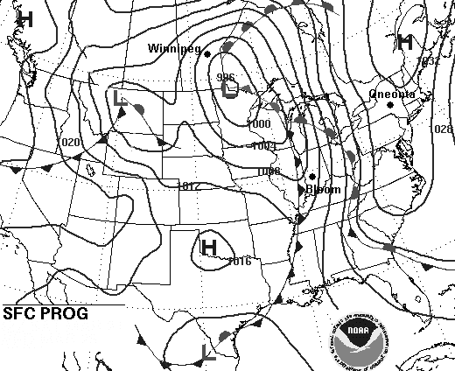

(18%) The cities of Oneonta, Bloomington Indiana, and Winnipeg Manitoba are marked with black dots. Write forecasts for each of these cities to occur at the time of the map. Your answers must be on the table below and show the forecast temperature, pressure, and present weather for each city. Pressure must be in whole millibars. For temperatures use Arctic, Polar, or Tropical (pick the one that comes closest based on the map). Present weather must be forecast the way we observed it in lab – anything falling or hanging in the air such as rain, snow, fog, thunderstorm, or none. Use one or two words (not symbols). Present weather is not actually shown on the map but everyplace has some kind of present weather.

|  |  |  |  |
| --- | --- | --- | --- |
|  | Temperature | Pressure | Present Weather |
| Oneonta |  |  |  |
| Bloomington |  |  |  |
| Winnipeg |  |  |  |