A SIMPLE APPARATUS FOR DYNAMIC MODELING
OF PAIRED CONVECTION CELLS

Laura Hurteau and Amanda Schulz, Adolescence Education Earth Science Majors
Dr. James R. Ebert, Earth Sciences Department
Nancy A. Elliott, Learning Support Services

Students must understand the fundamental process of convection if they are to grasp a wide variety of Earth processes, which may seem abstract owing to the scales on which they operate. Many teachers use simple models that employ differences in temperature and density to help students visualize convection. However, most of these models are incomplete or merely hint at convective circulation, rather than modeling it. A simple, inexpensive apparatus for modeling paired convection cells has been developed and constructed from inexpensive, readily available materials: a bread pan, vegetable oil, mylar gift wrap, a hot plate, metal bars, glass plates and cardboard. The model, which maintains dynamic circulation of two, adjacent, convecting cells, can be used to model high and low pressure systems in the atmosphere, convective circulation in Earth’s mantle and the motion of lithospheric plates by floating small pieces of cardboard on the oil.
Apparatus for dyanmic modeling of convection cells
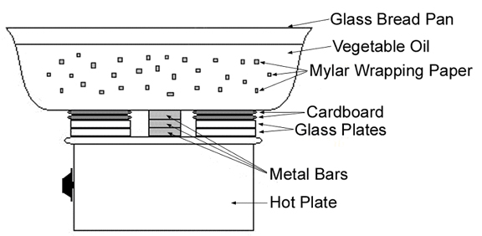
The need for better models of Earth processes, including a dynamic, multi-cell convection model, was brought to our attention by veteran earth science teachers. It became clear to us that the time constraints of teaching at the secondary level largely precluded these talented teachers from developing and testing such models. Through this project, we have demonstrated that pre-service teachers (science education majors) represent an untapped pool of expertise that can develop models, test them, refine them for scientific accuracy and share them with in-service teachers. We have done just that by presenting the dynamic convection model at the 2003 Annual Conference of the Science Teachers Association of New York State, and submitting a manuscript, which describes the model and its development to The Science Teacher, a journal of the National Science Teachers Association.

