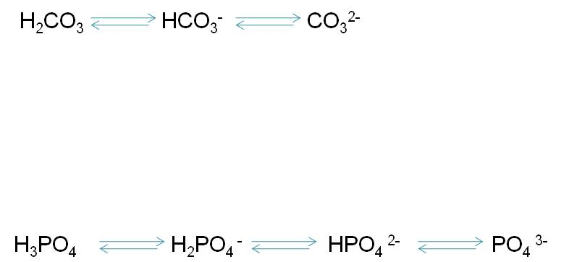

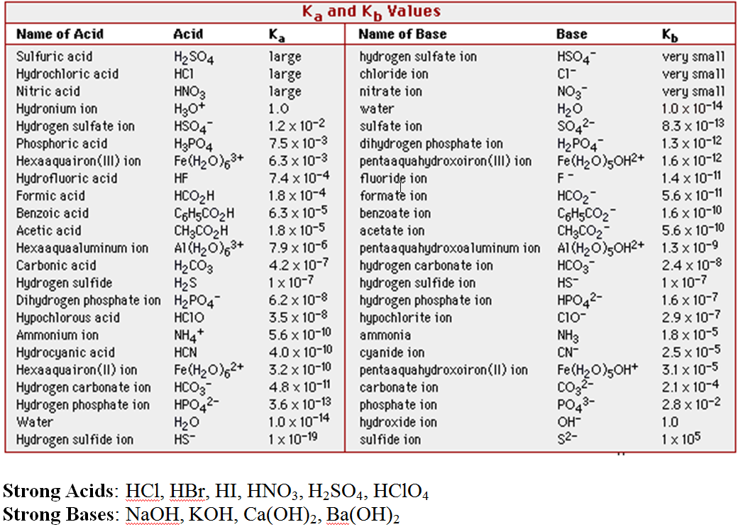
Compound | Cation | Anion | Acidic or Basic?
NaCN
KNO₃
NH₄Cl
NaHCO₂
Na₂CO₃
NH₄CN

