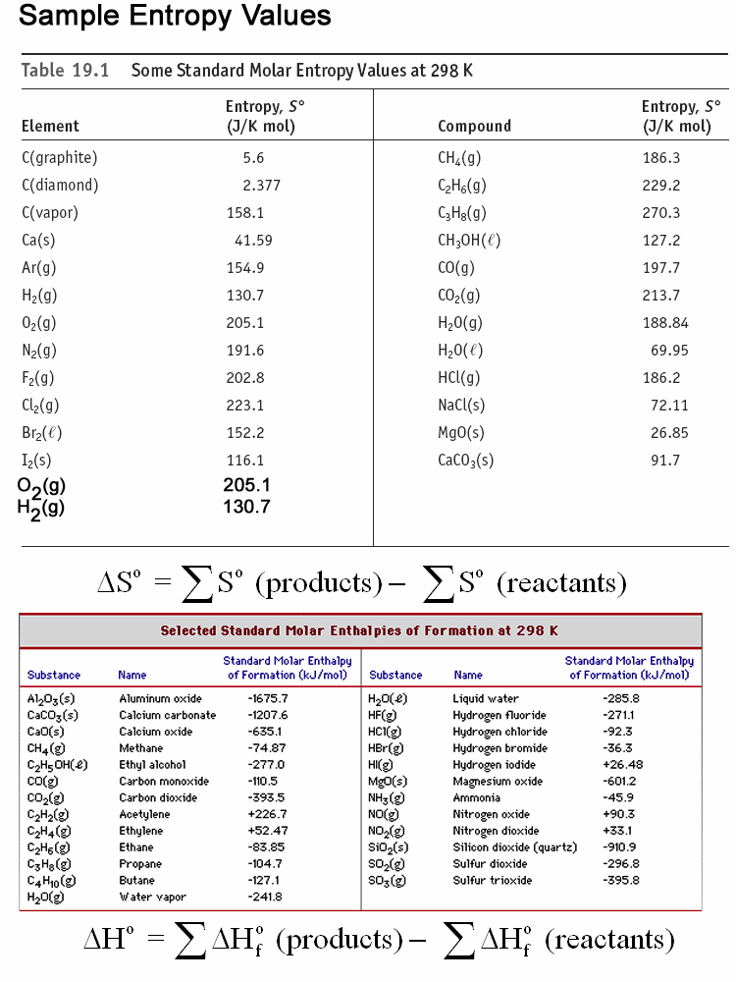

Is this reaction spontaneous at 25°C?

Predict the sign of the entropy change for the following reactions.

2CO2(*g*) →2CO(*g*) + O2(*g*)

2NO2(*g*) → N2O4(*g*)

NaCl(*s*) → NaCl(*aq*)

What is the entropy change for formation of rain?  
H2O(*g*) → H2O(*l*) 

ΔSuniverse = ΔSsystem + ΔSsurroundings 



At low temperatures:

At high temperatures:

Gibbs' Free Energy

ΔG = ΔH - TΔS