Phase Diagrams

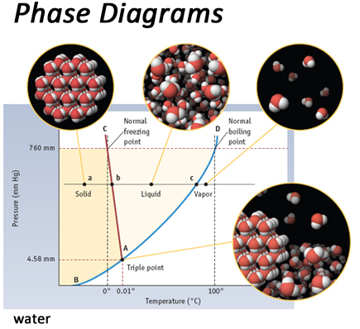

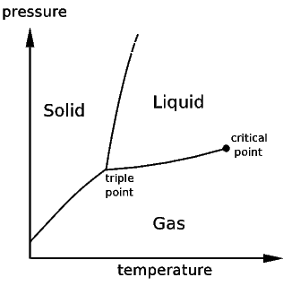
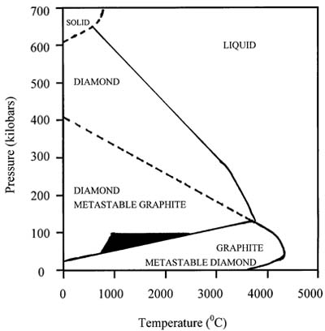

Clicker Questions: What form will the carbon take?

1. Graphite 1. Graphite
2. Diamond 2. Diamond

