General Chemistry I NAME: _____________________
Chem 111 Exam #3 November 30, 2012 Version #26

Some Equations and Constants for your use:

SHOW ALL WORK
1. 8 points
Consider electromagnetic radiation that delivers 2.00 x 10⁻¹⁹ J for each photon.

a. What is the frequency of the radiation, in Hz?

E = hν; ν = E/h = 2.00 x 10⁻¹⁹ J/6.626 x 10⁻³⁴ J = 3.02 x 10¹⁴ s⁻¹

b. What is the wavelength of this light, in nm?

λ x ν = c; λ = c/ ν = 3.00 x 108 m/s / 3.02 x 10¹⁴ s⁻¹ = 9.93 x 10⁻⁷ m = 993 nm

2. 4 points
Consider the electromagnetic spectrum below.
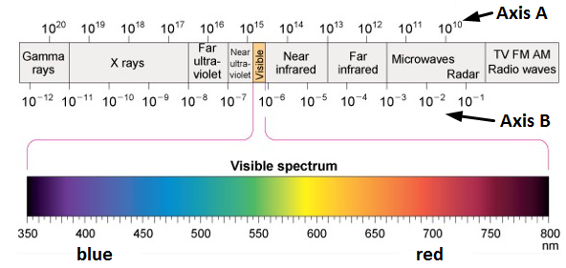
a. Give the correct label for Axis A: frequency (energy is acceptable)

b. Give the correct label for Axis B: wavelength

c. Which type of light has greater energy per photon? Radio or IR

d. Which type of light has greater frequency? X-rays or UV
3. 8 points
Fill in the following chart regarding orbitals.

number of orbitals number of electrons
that be can held

n = 3 shell 9 18

4p subshell 3 6

3p_{x} 1 2

2f subshell 0 0

4. 4 points
Give the orbital designation for each orbital pictured. For example, 2s or 4p_{x}.

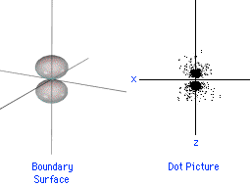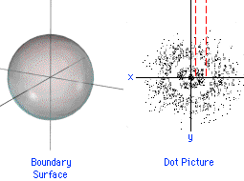
2p_{z} 3s

5. 4 points
For the orbital above on the left: how many planar nodes? 1

how many spherical nodes? 0
6. 7 points
A. Fill in the following charts to show the electron configuration of Mn. You need to fill in electron arrows and fill in the blanks below the boxes with what is appropriate to go there. That is, for each of the thick lines, you need to indicate what goes there in the diagram.

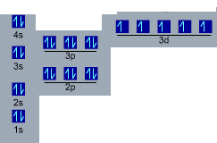
B. Is a Mn atom paramagnetic, or is it diamagnetic?

7. 4 points
In any format you prefer, indicate the electron configurations for each of the following:

a. Si 1s² 2s² 2p⁶ 3s² 3p²
[Ne] 3s² 3p²

c. the Mn³⁺ ion 1s² 2s² 2p⁶ 3s² 3p⁶ 3d⁴

8. 4 points
For each pair, indicate which is higher in energy:

a. the 2p orbitals of C or the 3p orbitals of Si

b. the highest energy electron in Na or the highest energy electron in Mg

9. 4 points
For each pair, which bond is longer?

a. C-C or C-O

b. C-C or C=C
10. 8 points
For each pair, indicate which is larger:

a. ionization energy of Li or ionization energy of F

b. radius of C or radius of Si

c. radius of F⁻ or radius of F⁺

d. size of the ion made by Na or size of the ion made by O

11. 4 points
What is ΔH for the following reaction? N₂(g) + 3 F₂(g) → 2 NF₃(g)
Bond energies:

N≡N = 945 kJ/mol
F-F = 155 kJ/mol
N-F = 283 kJ/mol

ΔH = [945 + 3(155)] kJ – [6(283)] kJ = -288 kJ

12. 12 points
Draw Lewis Dot structures for the following:
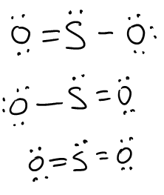
SO₂ CHCl₃ (all atoms bonded to C)
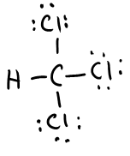
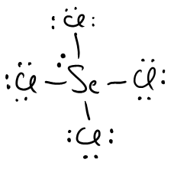

SeCl₄

13. 4 points
What is the driving force causing the formation of a covalent bond between two atoms?
Choose one.
a. the ability to fill valence shells, usually with an octet of 8 electrons

b. the ability for electrons on one atom to be near the nucleus of another atom

c. the ability of electrons to “pair up” with other electrons from other atoms

d. the ability of two nuclei to be closer to each other, increasing the strong nuclear force

14. 5 points
Give the formal charge for each of the noted atoms in the following Lewis structure.

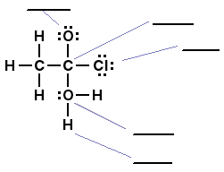top O = -1; C= 0 ; Cl = 0; lower O = +1; H = 0

16. 5 points
In the area below, sketch what the periodic table would look like if all orbital subshells could have exactly two orbitals instead of the way it really works (s = 1 orbital, p = 3 orbitals, d = 5 orbitals, etc.). Include just boxes in appropriate rows and columns, and do so for the first 4 periods of the periodic table. Do not put in element symbols. You're making a picture with a bunch of properly positioned boxes.
17. 15 points
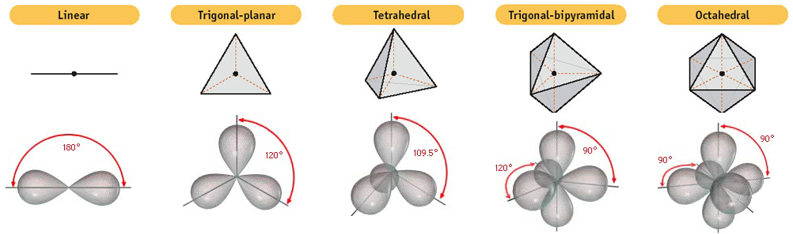

For each of the following molecules, give the electron-pair geometry, the molecular geometry, the bond angles, and determine the molecular polarity. Space is given to show your work.

SO₂ SO₃

3 structural pairs 3 structural pairs
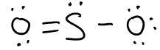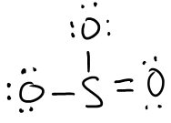

electron-pair geometry: trigonal planar electron-pair geometry: trigonal planar

molecular geometry: bent molecular geometry: trigonal planar

bond angles: 120º bond angles: 120º

polar or nonpolar? polar polar or nonpolar? nonpolar

SF₂
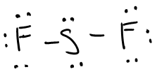
4 structural pairs

electron-pair geometry: tetrahedral

molecular geometry: bent

bond angles: 109º

polar or nonpolar? polar

