Chemistry 111 – 2015 Name: ________________________
Exam #1 September 24, 2015
N_{A} = 6.022 x 10²³
1. How many protons, neutrons and electrons are found in an ion of the isotope ³⁴S²⁻
___ protons ___ neutrons ___ electrons

2. Define:
Isotopes:

Allotropes:

3. Elements in the same ___________ of the periodic table tend to have similar properties.

4. Give formulas for the following:
ammonium phosphate: boron trichloride:
disulfur decafluoride: potassium sulfate:

5. Name the following:
MgCl₂ : S₂O₃ :
Na₂SO₃ : AlBr₃ :

6. Identify the following compounds as covalent or ionic:
C₂H₆ covalent or ionic S₂Cl₄ covalent or ionic
Mg(NO₃)₂ covalent or ionic NH₄ClO₄ covalent or ionic

7. How many atoms of hydrogen are found in 8.40 mol N₂H₄? ________________________
8. Balance the following reaction:

___ Al₂(SO₃)₃ + ___ HCl ___ AlCl₃ + ___ SO₂ + ___ H₂O

8. Copper (Cu) has two isotopes. Their masses are:
⁶³Cu = 62.93 aum ⁶⁵Cu = 64.93 amu
Which isotope is present in greater abundance? ⁶³Cu or ⁶⁵Cu

9. Consider the reaction of butane with oxygen:
2 C₄H₁₀ + 13 O₂ 8 CO₂ + 10 H₂O

If 5.6 mol C₄H₁₀ are reacted with excess oxygen, what amount (in moles) of H₂O can be formed?

10. Why do we use “moles” to describe chemical amounts?

11. What is the molar mass of (NH₄)₂SO₃?

12. Well mixed, filtered salt water represents:
element compound pure substance
homogeneous mixture heterogeneous mixture

Long Answer Questions: You MUST Show All Work
Some molar masses: MgSO₄: 120.36 g/mol Fe₂O₃: 159.69 g/mol
Na₂SO₄: 142.04 g/mol

13. Calculate the percent composition of oxygen in MgSO₄.

14. What is the weight of one gallon of gasoline (in pounds)?
Density = 0.72 g/cm³
1 gallon = 3.785 L
1 pound = 454 g

15. A 43.09 gram sample of a hydrate of Na₂SO₄ was heated thoroughly in a porcelain crucible, until its weight remained constant. After heating, 22.82 grams of the anhydrous compound remained. What is the formula of the compound?

16. A compound is found to contain 43.64% phosphorus and 56.35 % oxygen by weight. What is the empirical formula?

17. Metallic iron is made by the reaction of iron oxide with carbon:
2 Fe₂O₃(s) + 3 C(s) 4 Fe(s) + 3 CO₂(g)
If one pound (454 g) Fe₂O₃ are reacted with excess C, what mass of CO₂ is formed?

18. A compound is found to have the empirical formula C₄H₅. It’s mass spectrum is below.
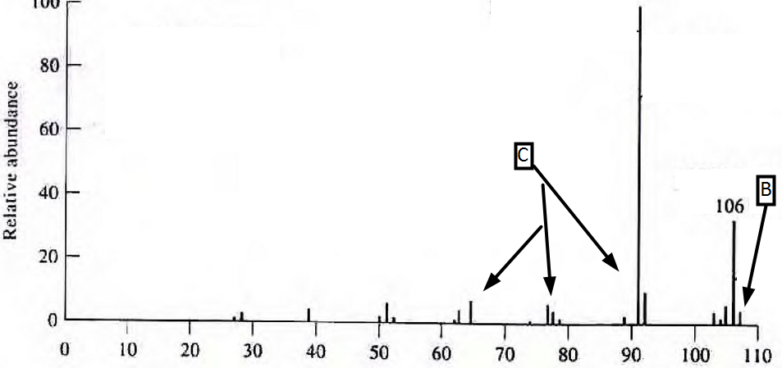
a. What is the molecular formula of the compound? __________

b. What leads to the peak labeled “B”? Give a one-sentence general description.

c. What leads to the peak labeled “C”? Describe in one or two sentences. You are looking for the general cause, not the specific chemical entity.

I swear I have cheated in no way during this exam: _________________________

