General Chemistry I NAME: ________________________
Chem 111-01 Exam #3 Fall 2015

Some Equations and Constants for your use:
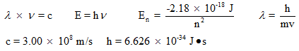

1. Light and Energy
Consider electromagnetic radiation that delivers 2.00 x 10⁻¹⁹ J for each photon. Include units.

a. What is the frequency of the radiation, in Hz?

________________

b. What is the wavelength of this light, in nm?

________________

2. Electromagnetic Spectrum
Consider the electromagnetic spectrum below. The labels for the x-axis numbers have been omitted.
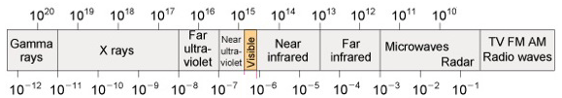

a. Which x-axis represents wavelength: top or bottom

b. increasing wavelength = increasing or decreasing frequency

c. increasing frequency = increasing or decreasing photon energy

d. Which type of radiation has greater energy per photon? Radio or IR

e. Which type of radiation has greater frequency? X-rays or UV

3. Fill in the following chart regarding orbitals. The answer to at least one of these is zero.

number of orbitals number of electrons
that can be held

n = 3 shell ______ ______

4p subshell ______ ______

3p_{x} orbital ______ ______

2f subshell ______ ______

5g subshell ______ ______

4. Orbital Shapes
Give the orbital designation for each orbital pictured. For example, 2s or 4p_{x}.

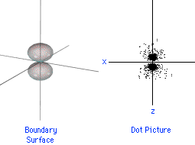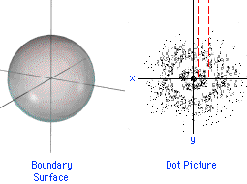
Orbital: Orbital:

how many planar nodes? _______ how many planar nodes? _______

how many spherical nodes? _______ how many spherical nodes? _______

Consider the wavefunction below. r, x, and y = represent distances of the electron from the nucleus. In what regions would it equal zero (that is, have a node)? (Answer something like “when z = 0” and there can be more than one answer.)

$ψ=\left(3-r\right)xy e^{-r}$

5.
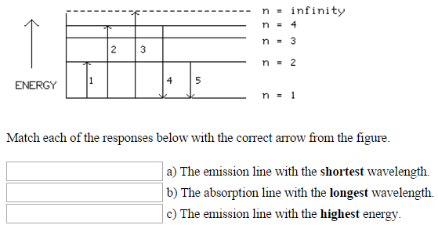

6. Which of the following sets of quantum numbers are allowed (circle each that is allowed):

a. n = 3, l = 2, m_{l} = -1

b. n = 3, l = 3, m_{l} = 0

c. n = 9, l = 0, m_{l} = 0

7. Complete the electron configuration for nitrogen using the diagram below. I have labeled the 1s subshell. You need to add arrows for electrons and label all the other subshells.

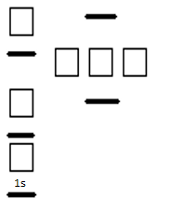

Is a nitrogen atom paramagnetic or diamagnetic?

8. Give electron configurations for the following (using spdf (1s² 2s² etc. notation, or noble gas notation):

a. Na

b. S²⁻

c. Mg²⁺

d. Cr³⁺

9. Trends!
An atom has the following attributes:

a. it is smaller than As
b. it is smaller than Te
c. it has lower energy orbitals than Se
d. it is larger than Cl
e. it forms a 1- ion

What element is it? _______

Which is larger:

Radius of: P or As

Radius of: Ar or Na

Radius of: Na⁺ or F⁻

Radius of: O or O²⁻

Ionization energy of: S or Ar

Ionization energy of: Na or Be

Ionization energy of: N or O

Energy of 2p orbital in C or Energy of 2p orbital in O

Energy of 2p orbital in C or Energy of 3p orbital in Si

Thermochemistry
10.
Given the standard enthalpy changes for the following two reactions:
(1) 2C(s) + 2H₂(g)C₂H₄(g)...... ΔH° = 52.3 kJ
(2) 2C(s) + 3H₂(g)C₂H₆(g)......ΔH° = -84.7 kJ
what is the standard enthalpy change for the reaction:
(3) C₂H₄(g) + H₂(g)C₂H₆(g)......ΔH° = ?

11.
A student determines the heat of dissolution of solid magnesium chloride using a coffee-cup calorimeter of negligible heat capacity.
When 0.630 g (= 0.00662 mol) of MgCl₂(s) is dissolved in 119.00 g of water, the temperature of the solution increases from 25.00 to 27.19°C. Calculate the enthalpy of dissolution of MgCl₂(s) in kJ/mol. Assume the specific heat of the solution is 4.184 J/g°C.

ΔH_{dissolution} = kJ/mol

12.
Using standard heats of formation, calculate the standard enthalpy change for the following reaction.
2H₂S(g) + 3O₂(g)2H₂O(l) + 2SO₂(g)

ΔH_{f}º , kJ/mol
H₂S(g) -20.6
H₂O(l) -285.8
SO₂(g) -296.8

ANSWER: kJ

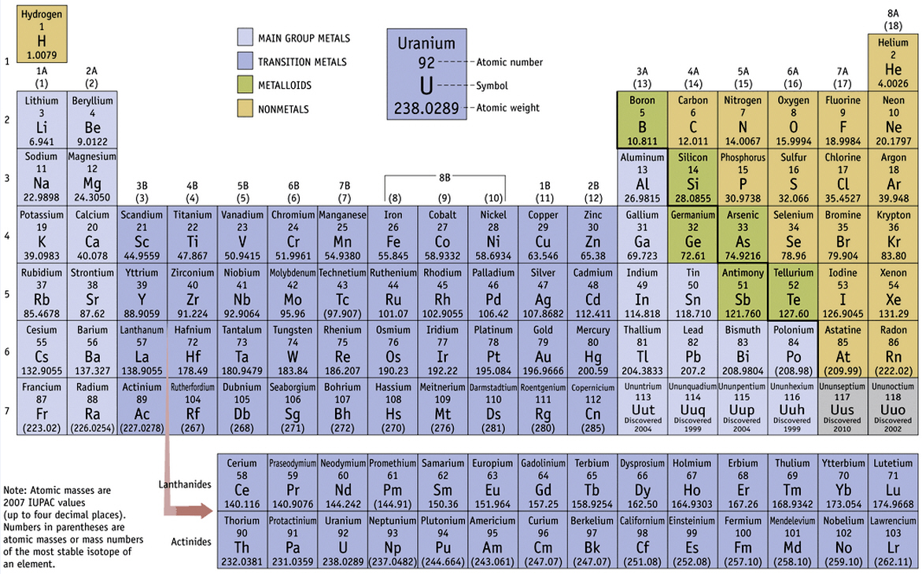

Take Home Extra Credit: You can work with anyone in our class but no one else.

13. In the area below, sketch what the periodic table would look like if:

a) all orbital subshells (s, p d, f, etc.) could have exactly two orbitals instead of the way it really works (s = 1 orbital, p = 3 orbitals, d = 5 orbitals, etc.).

and

b) three spin quantum numbers were allowed +1/2, 0, and -1/2.

Any other quantum number rules remain unchanged. Include just boxes in appropriate rows and columns, and do so for the first 4 periods of the periodic table. Do not put in element symbols. You're making a picture with a bunch of properly positioned boxes.

