General Chemistry I NAME: _____________________
Chem 111 Exam #4 - Vining December 11, 2015

1. 4 pts
What is the driving force causing the formation of a covalent bond between two atoms?
Choose one.
a. the ability to fill valence shells, usually with an octet of 8 electrons

b. the ability for electrons on one atom to be near the nucleus of another atom

c. the ability of electrons to “pair up” with other electrons from other atoms

d. the ability of two nuclei to be closer to each other, increasing the strong nuclear force

2. 3 pts How many valence electrons does each of the following have:

a) N ____ b) Mg ____ c) S²⁻ ____

3. 12 pts
Draw Lewis Dot structures for the following: If resonance forms exist, only draw one.

SO₂ CHCl₃ (all atoms bonded to C)

BrCl₅

4. 4 pts
For each pair, which bond is longer?

a. C-C or C-O

b. C-C or C=C

5. 4 pts
For each pair, which bond is stronger?

a. C-C or Si-Si

b. C-C or C=C

6. 6 pts
For each pair, which bond is more polar?

a. F-F or H-Cl

b. C-O or Si-O

Why is a C-O bond polar?

7. 6 pts
What is ΔH for the following reaction? N₂(g) + 3 F₂(g) → 2 NF₃(g)
Bond energies:

N≡N = 391 kJ/mol
F-F = 155 kJ/mol
N-F = 283 kJ/mol

8. 15 pts
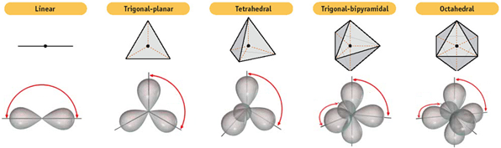

For each of the following molecules, give the Lewis structure, the electron-pair geometry, the molecular geometry, the bond angles, and determine the molecular polarity. Space is given to show your work.
HCN IF₄⁻

electron-pair geometry: electron-pair geometry:

molecular geometry: molecular geometry:

bond angles: bond angles:

polar or nonpolar? polar or nonpolar?

SF₂

electron-pair geometry:

molecular geometry:

bond angles:

polar or nonpolar?
9. 6 pts
Draw all resonance structures for SO₂.

What is the average bond order for each sulfur-oxygen bond? _______

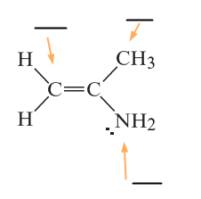
10. 6 pts
What hybrid orbitals are used by each indicated atom?

11. 6 pts
How many sigma and pi bonds are in
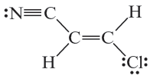
the structure?

sigma: _____ pi: _____

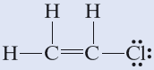
12. 6 pts
Describe what orbitals are used to form each
of the following bonds in CH₃CH₂Cl. Your answer
should use language like “an sp² orbital on N overlaps
with an sp³ orbital on O”.

First C-C bond:

Second C-C bond:

C-H bond:

13. 8 pts
Determine the formal charges on all atoms in these resonance structures of the OCN⁻ ion.
Draw a box around the most stable resonance structure.
Draw an arrow pointing to the least stable resonance structure.

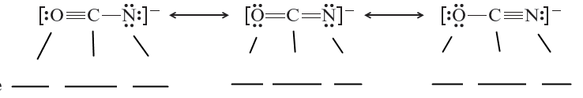

14. 6 pts
Are these two shapes: conformations or isomers

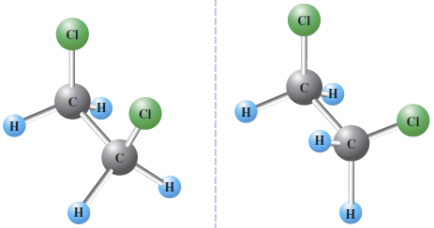

How do you know?

These two structures are a class of compounds called cycloalkanes.

Are these two shapes: conformations or isomers

Explain why.

15. 6 pts
Fill electrons into the following MO diagram for the C₂ molecule. Notice that 1s orbitals are not included in this diagram.

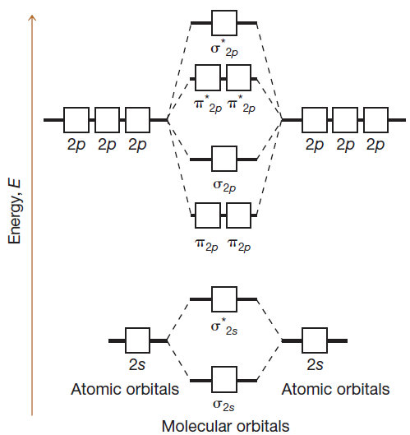

What is the carbon-carbon bond order? _____

Is C₂: diamagnetic or paramagnetic

16. 2 pts

What is an antibond?

