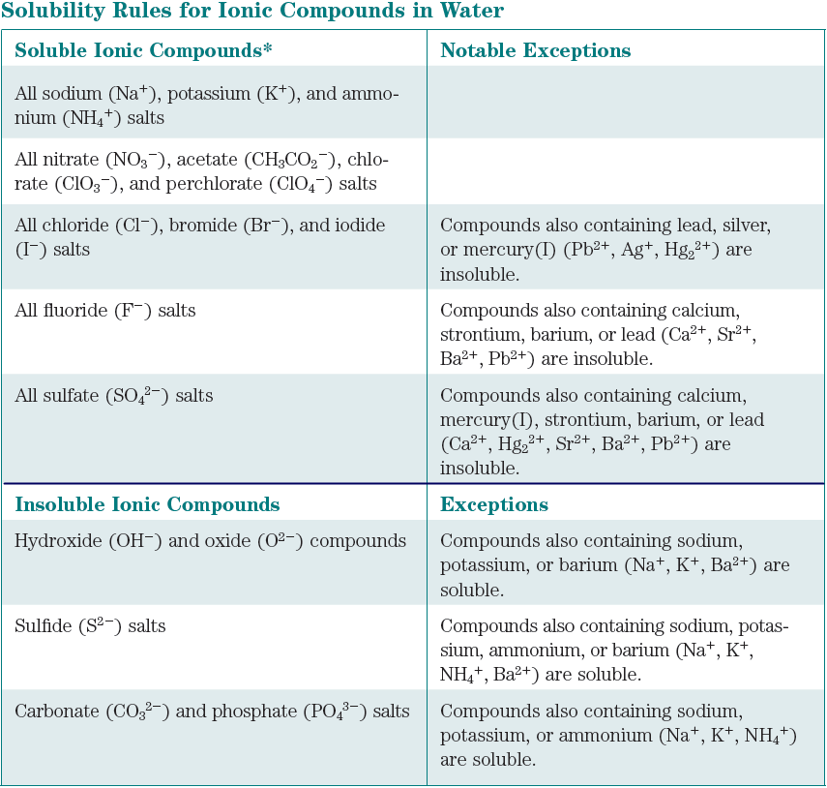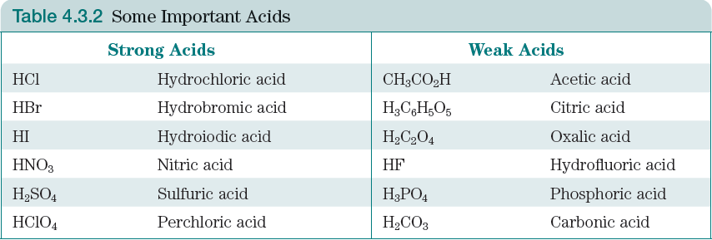Compounds in Aqueous Solution

**All** acids are soluble: only strong acids are strong electrolytes

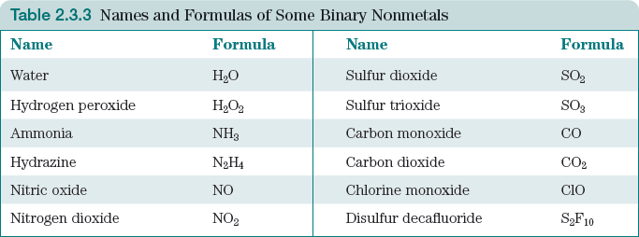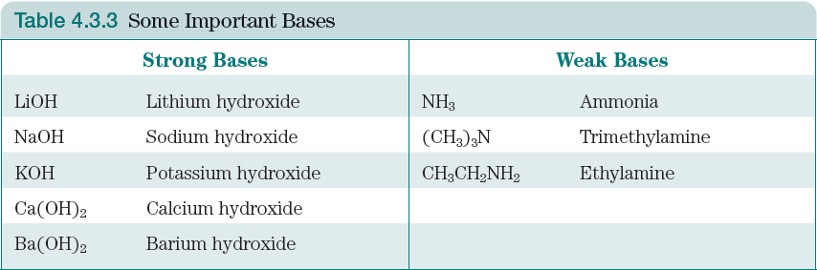

Soluble molecular compounds are nonelectrolytes, written together: CO2(aq)

**Water** is the solvent and written as liquid: H2O(ℓ)

Strong Electrolytes, separate ions(aq):Na+(aq) + Cl-(aq)

Insoluble compounds are written as formula(s): Fe(OH)3(s)

Special case: Ca(OH)2 is insoluble: Ca(OH)2(s)

Weak Electrolytes, formula(aq): H3PO4(aq)