Write out reaction based on a double displacement

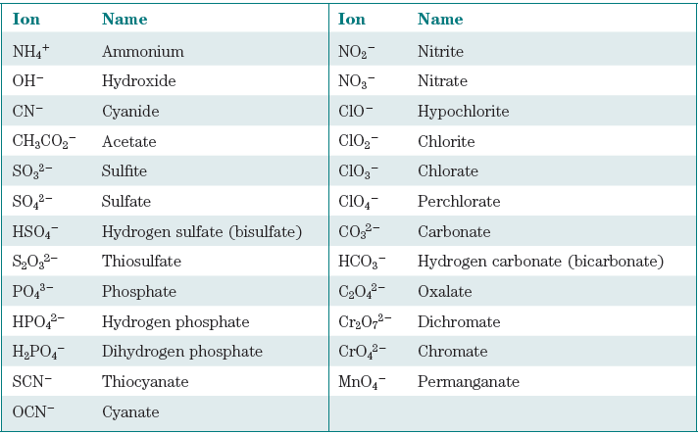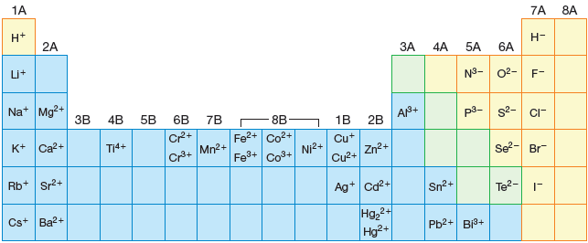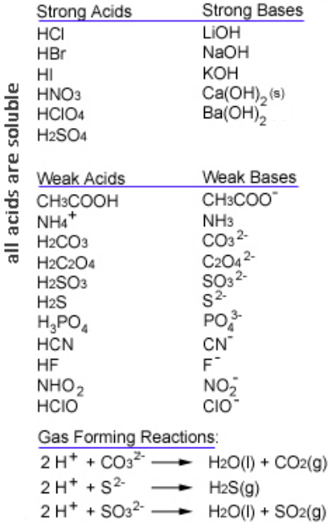

Common Ions

Acids and Bases

What to look for:

* Do two of the ions result in an insoluble compound?
* Are an acid and a base present?
* Be sure to look for anions that are bases, even in insoluble reactants
* Are one of the gas-forming anions present

Acid-Base Rules:

* If the base is strong, OH- is the base and H2O is a product.
* If both acid and base are strong, NIE is simple H+ + OH- --> H2O

PPT Rules: If two ions form an insoluble compound, a precipitation reaction occurs. A solid is formed and usually the other two ions remain in solution. The two ions remaining in solution are spectator ions and not included in the NIE.

Gas Forming Acid-Base Rxns:

If the base is:

CO32-, a gas forming reaction occurs. The product H2CO3 decomposes to give H2O(l) + CO2(g)

SO32-, a gas forming reaction occurs. The product H2SO3 decomposes to give H2O(l) + SO2(g)

S2-, the H2S product is a gas (g), not aqueous (aq).

Rules:

* All acids are soluble (aq).
* Use solubility rules to determine solubility of ionic compounds.
* If a product is insoluble, ppt reaction occurs
* If an acid ***and*** a base are reactants, an acid-base reaction occurs
* Acids use H+ ion as the cation in the double displacement

Rules:

* Soluble ionic compounds and strong acids are strong electrolytes: exist as separate ions in solution (aq).
* Solids are written together (s).
* Weak acids and covalent compounds are non-ionized; written together, usually (aq)

Write full ionic equation

Write net ionic equation