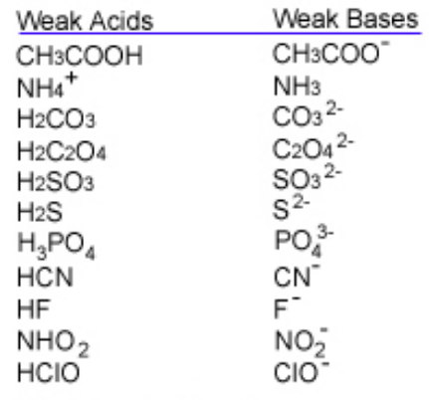
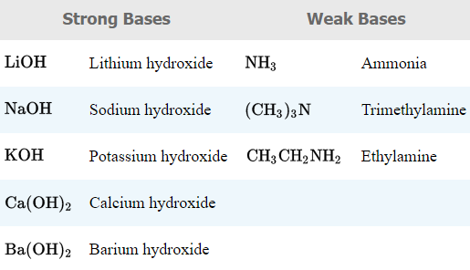
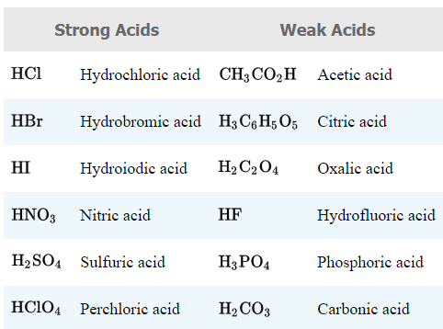
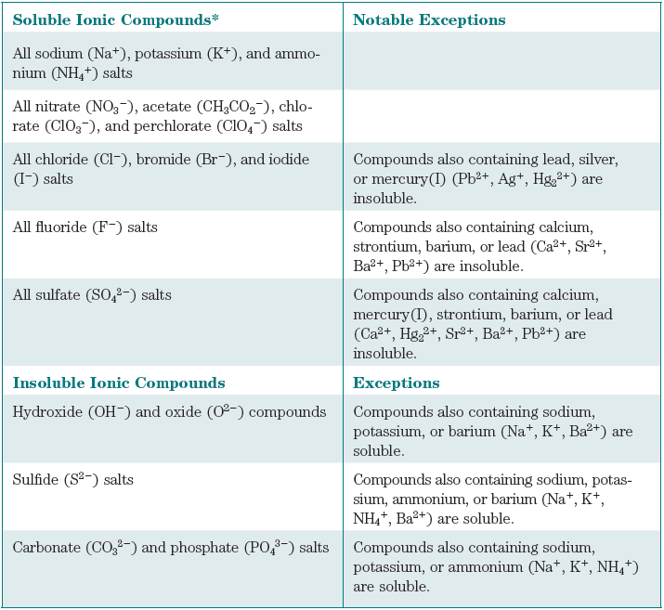
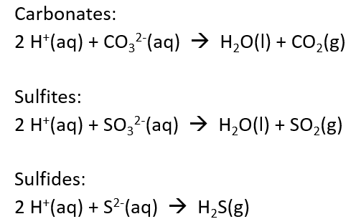
Gas-Forming Reactions:

How to Write Compounds in Solution:
Strong electrolytes are written as separate ions.
Strong Electrolytes: Soluble salts and strong acids and bases.
Ca(NO₃)₂(aq) is written as Ca²⁺(aq) + 2 NO₃⁻(aq)
HCl is written as H⁺(aq) + Cl⁻(aq)
All acids are soluble. Weak acids and nonelectrolytes are written in their non-ionized form:
CH₃CO₂H(aq) or CH₃OH(aq), water is written as liquid H₂O(l)
Insoluble salts are written as the full compound:
CaCO₃(s)

