When atoms combine
- metal + metal = alloy
- metal + nonmetal = ionic compound
- nonmetal + nonmetal = covalent compound or ionic compound

Interactive Table 2.3.1: Naming Covalent Compounds
1. The first word in the compound name is the name of the first element in the compound
formula. If the compound contains more than one atom of the first element, use a prefix
(Table 2.3.2) to indicate the number of atoms in the formula.
CS₂ First word in compound name: carbon
N₂O₄ First word in compound name: dinitrogen

2. The second word in the compound name is the name of the second element in the formula
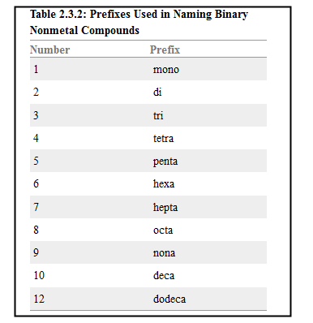
that has been changed to end with -ide. In all cases, use a prefix (Table 2.3.2) to indicate
the number of atoms in the formula.
CS₂ Second word in compound name: disulfide
N₂O₄ Second word in compound name: tetraoxide

3. The compound is named by combining the first and second words of the compound
name. CS₂ carbon disulfide
N₂O₄ dinitrogen tetraoxide

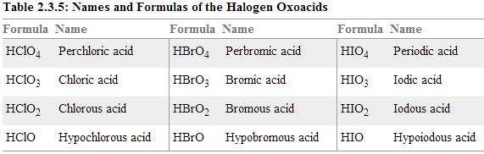
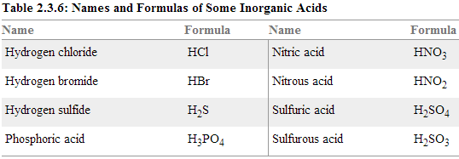
Selected Hydrocarbons with the Formula C_{n}H_{2n+2}
Hydrocarbon | Name
CH₄ | Methane
C₂H₆ | Ethane
C₃H₈ | Propane
C₄H₁₀ | Butane
C₅H₁₂ | Pentane
C₆H₁₄ | Hexane
C₈H₁₈ | Octane
C₁₀H₂₂ | Decane

Ions and Ionic Compounds

Monatomic Ions
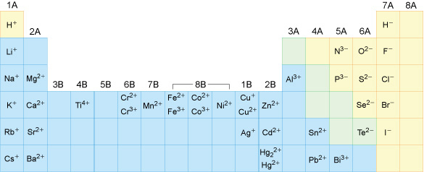

Polyatomic Ions
Ion | Name |  | Ion | Name
NH₄⁺ | Ammonium |  | NO₂– | Nitrite
OH– | Hydroxide |  | NO₃– | Nitrate
CN– | Cyanide |  | ClO– | Hypochlorite
CH₃CO₂– | Acetate |  | ClO₂– | Chlorite
SO₃^{2–} | Sulfite |  | ClO₃– | Chlorate
SO₄^{2–} | Sulfate |  | ClO₄– | Perchlorate
HSO₄– | Hydrogen sulfate (bisulfate) |  | CO₃^{2–} | Carbonate
S₂O₃^{2–} | Thiosulfate |  | HCO₃– | Hydrogen carbonate (bicarbonate)
PO₄^{3–} | Phosphate |  | C₂O₄^{2–} | Oxalate
HPO₄^{2–} | Hydrogen phosphate |  | Cr₂O₇^{2–} | Dichromate
H₂PO₄– | Dihydrogen phosphate |  | CrO₄^{2–} | Chromate
SCN– | Thiocyanate |  | MnO₄– | Permanganate
OCN– | Cyanate

