Reaction Stoichiometry: Balanced Equation give Mole – Mole Relationships
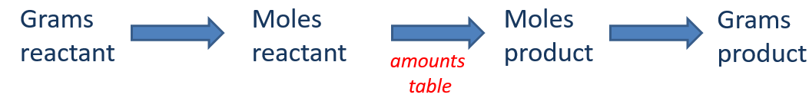
Balanced equation gives mol – mol relationships (conversion factors):
CH₃CH₂OH + 3 O₂ 2 CO₂ + 3 H₂O

Pb(NO₃)₂(aq) + 2 NaCl(aq) --> PbCl₂(s) + 2 NaNO₃(aq)
If you have 5.00 moles of Pb(NO₃)₂, how many moles of PbCl₂ can you make?
How many moles of NaNO₃ can you make?

If we react 115 g of CH₃CH₂OH, what mass of H₂O is formed?

Theoretical Yield and Percent Yield
Alum Synthesis Experiment:
2 Al(s) + 2 KOH(aq) + 4 H₂SO₄(aq) + 22 H₂O(l) 2 KAl(SO₄)₂ ⋅12H₂O(s) + 3 H₂(g)

Calculation of Theoretical Yield: Map: grams reactant moles reactant moles product grams product

If you react 1.083 g Al, what mass of alum (KAl(SO₄)₂ ⋅12H₂O(s)) is theoretically possible to form?
$$\text{1.083 g Al × }\frac{\text{1 mol Al}}{\text{26.98 g Al}}\text{ = 0.04014 }\text{mol}\text{ Al }$$
$$\text{0.04014 }\text{mol}\text{ Al × }\frac{\text{1 mol alum}}{\text{1 mol Al}}\text{ = 0.04014 }\text{mol}\text{ alum }$$
$$\text{0.04014 }\text{mol}\text{ alum × }\frac{\text{474.37 g alum}}{\text{1 mol alum}}\text{ = 19.0 g }\text{KAl}\text{(S}{\text{O}}_{\text{4}}{\text{)}}_{\text{2}}\text{°12}{\text{H}}_{\text{2}}\text{O }$$
This is the “theoretical yield.”

Calculation of Percent Yield:
If you do the reaction using 1.083 g Al and obtain 15.2 g KAl(SO₄)₂ ⋅12H₂O(s), what is the percent yield?
$$\text{Percent Yield = }\frac{\text{Actual Yield (g)}}{\text{Theoretical Yield (g)}}\text{ × 100\%}$$

Using Amounts Tables:
If we react 132 grams of CH₃CH₂OH, how many grams of H₂O are formed, how many grams of O₂ react?
CH₃CH₂OH + 3 O₂ 2 CO₂ + 3 H₂O

Limiting Reactants: When multiple reactants are used, one will run out and limit the reaction.
A cake recipe calls for 3 eggs, 2 cups of flour, and 3 teaspoons of sugar. If you have:
- 9 eggs
- 8 cups of flour
- 12 teaspoons of sugar
How many cakes can you make?

2 CO(g) + O₂(g) 2 CO₂(g)
If you start with 4 CO molecules and 3 O₂ molecules, which mixture will result?

Determining the Limiting Reactant:
If you have 5 P₄ molecules and 20 Cl₂ molecules, which will run out first? How many PCl₃ molecules can form?
P₄ + 6 Cl₂ 4 PCl₃

Reaction to make iron (steel) from iron ore:
If you react 496 g Fe₂O₃ with 122 g C, which is the limiting reactant? What mass of Fe can be produced? What mass of the reactant in excess remains?
molar mass Fe₂O₃ =159.69 g/mol

2 Fe₂O₃ + 3 C 4 Fe + 3 CO₂

Chemical Analysis: Determining Chemical Formulas or Chemical Composition using Reactions
Example 1:
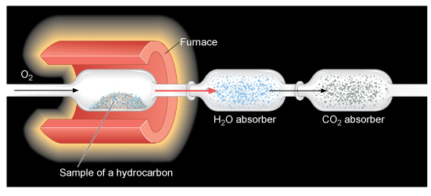

A 5.486 gram sample of a compound containing C, H and O is analyzed by combustion analysis and 9.136 grams of CO₂ and 2.993 grams of H₂O are produced. What is the empirical formula?

Example 2:
A 8.878 gram sample of manganese is heated in the presence of excess sulfur. A metal sulfide is formed with a mass of 14.06 g. Determine the empirical formula of the metal sulfide.

Example 3:
A sample of a substance with the empirical formula XCl₂ weighs 0.5539 g. When it is dissolved in water and reacted with AgNO₃, all its chlorine is converted to insoluble AgCl. The mass of the resulting AgCl is found to be 1.1807 g. The chemical reaction is
XCl₂ + 2 AgNO₃ 2 AgCl + X(NO₃)₂ X is an unknown element
What is the molar mass of XCl₂?

What is the molar mass of X?

What element is X?

