Reaction Stoichiometry
Pb(NO₃)₂(aq) + 2 NaCl(aq) --> PbCl₂(s) + 2 NaNO₃(aq)

If you have 5 moles of Pb(NO₃)₂, how many moles of PbCl₂ can you make?
If you have 5 moles of NaCl, how many moles of PbCl₂ can you make?

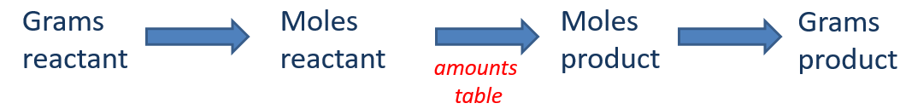
CH₃CH₂OH + 3 O₂ 2 CO₂ + 3 H₂O
If we react 100 grams of CH₃CH₂OH, how many grams of H₂O are formed?

Limiting Reactants
A cake recipe calls for 3 eggs, 2 cups of flour, and 3 teaspoons of sugar. If you have:
- 9 eggs
- 8 cups of flour
- 12 teaspoons of sugar
how many cakes can you make?

