Rules for Determining Oxidation Numbers: Chem 111 Redox Worksheet

Oxidation = loss of electrons
Reduction = gain of electrons Zn (s) + Cu²⁺(aq) Zn²⁺(aq) + Cu(s)

Oxidizing agent = oxidant = gains electrons
Reducing agent = reductant = loses electrons

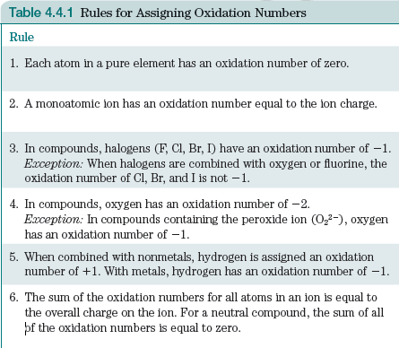

Oxidation Number Examples:

1. O in O₂ 5. O in OF₂

2. N in NO₂ 6. Cl in NaOCl

3. N in NO₃⁻ 7. O in H₂O

4. Na in NaCl 8. H in H₂O
Recognizing Oxidation-Reduction Reactions

Oxidation = loss of electrons = increase in ox #
Reduction = gain of electrons = decrease in ox #

4 Fe + 3 O₂ 2 Fe₂O₃

Examples:

N₂ + 2 O₂ N₂O₄

Pb(s) + PbO₂(s) + 2 H₂SO₄(aq) 2 PbSO₄(s) + 2 H₂O(l)

MnO₄⁻(aq) + 5 Fe²⁺(aq) + 8 H⁺(aq) Mn²⁺(aq) + 4 H₂O() + 5 Fe³⁺(aq)

2 H₂O₂(aq) O₂(g) + H₂O(l)

CaCO₃(s) CaO(s) + CO₂(g)

