1.Choose all that apply below.
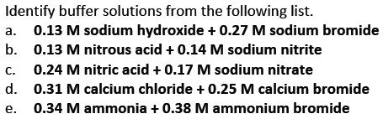
2.
3.

4.
5.
Which of the following acid-base pairs would you use to make a buffer of pH = 7.6?
Which species would be present in higher concentration, the acid or the base?
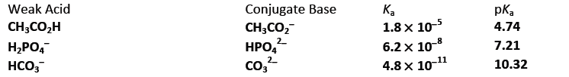

6.
Below is a plot for the titration of a weak, diprotic acid H₂SO₃ with NaOH. I
Indicate what chemical entity or entities are present at each of the indicated points (A – E).
Estimate the K_{a} values for H₂SO₃ and HSO₃⁻.

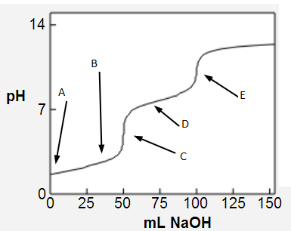

7.
The K_{a} value of HNO₂ is 4.5 x 10⁻⁴. Draw an alpha plot for the HNO₂/NO₂⁻ system. Label both axes.
8.
The fully acidic form of the amino acid valine is,
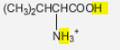
The two acidic H atoms are highlighted. The pKa of the COOH acid group is 2.32; that of the NH3+ group is 9.61.
Which form will the amino acid take at pH = 7?
Which form will the amino acid take at pH = 12?
9. The Al³⁺ concentration in a saturated solution of aluminum hydroxide is measured and found to be 2.85E-9 M. Use this information to calculate a K_{sp} value for aluminum hydroxide.
OR
The solubility of Ni(CN)₂ is measured and found to be 2.22E-6 g/L. Use this information to calculate a K_{sp} value for nickel(II) cyanide.

10.
Calculate the solubility of iron(II) hydroxide, Fe(OH)₂ in units of grams per liter.
K_{sp}(Fe(OH)₂) = 7.9E-15.

11.
a) Is CaCO3 more soluble in pure water, or in a solution of Na2CO3?
b) Calculate the solubility of CaCO₃ (a) in pure water and (b) in a solution in which [CO₃²⁻] = 0.174 M.

12. Identify the Lewis acid and Lewis base in this reaction:
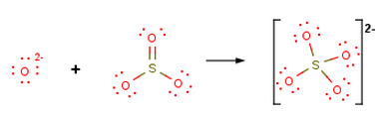

13. In the presence of excess OH⁻, the Zn²⁺(aq) ion forms a hydroxide complex ion, Zn(OH)₄²⁻. Calculate the concentration of free Zn²⁺ion when 1.64E-2 mol Zn(NO₃)₂(s) is added to 1.00 L of solution in which [OH⁻ ] is held constant (buffered at pH 12.40). ForZn(OH)₄²⁻, K_{f} = 4.6E17.

