Chem 112 – 2020 Section 1 Vining
Practice Exam #2
1. For a reaction to actually occur, it must be favored by:
a. thermodynamics c. either thermodynamics or kinetics
b. kinetics d. both thermodynamics and kinetics

2. a) Is the salt MgSO₄ more soluble in water at 5 ºC or at 35 ºC?
a) more soluble
b) less soluble
c) more information is needed, and that information is: _________________________

b) Describe the states of CO₂ solubility for a bottle of Diet Coke:
i) before it is open: saturated unsaturated supersaturated
ii) just after opening: saturated unsaturated supersaturated
iii) after going “flat”: saturated unsaturated supersaturated
iv) in which state is the solubility of CO₂ greater: before opening or after opening
3. Of the following compounds, which are expected to be highly soluble in water? Circle all that apply.

CF₄ CH₃OH SH₂ CH₃CH₃
4. Soap is composed of surfactant molecules. Surfactant molecules are:
a) hydrophilic b) hydrophobic c) both hydrophilic and hydrophobic

5. What is the primary reason water and oil do not mix?
a) if they did, many strong hydrogen bonds would need to be broken
b) in order to do so, the water would need to first be vaporized, which requires too much energy
c) if they did, the entropy of water would decrease markedly
d) the intermolecular forces between the nonpolar molecules are too strong
6. The reaction NH₄NCO (NH₂)₂CO was performed and data obtained for the concentration of NH₄NCO over time. The following plots were made from the data.

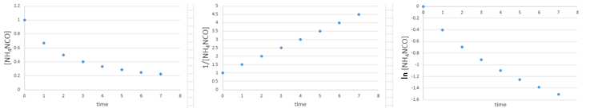
What is the order of the reaction with respect to NH₄NCO?
a. zero order b. first order c. second order d. cannot be determined from the plots alone

7. Write the equilibrium constant expression for each reaction:

P4(g) + 6 Cl₂(g) 4 PCl₃(g)

NH₃(g) + H₂S(g) NH₄HS(s)

8. The equilibrium 2 SO2Cl2(g) 2 SO2(g) + 2 Cl2(g) has an equilibrium constant of K = 22.6. What is the value of K for the equilibrium written as: SO2(g) + Cl2(g) SO2Cl2(g)?

(a) 22.6 (b) 0.0442 (c) 511 (d) 0.00196 (e) 0.210

9. The following reaction is 2nd–order in NO₂ in and zero–order in CO. Write the rate law for the reaction.

NO₂ + CO NO + CO₂ Rate = _________________________________

10. Two mechanisms are proposed for the reaction,
(CH₃)₂C=CH₂ + H₂O (CH₃)₃COH
Mechanism A: Step 1. (CH₃)₂C=CH₂ + H₂O (CH₃)₃COH

Mechanism B: Step 1. (CH₃)₂C=CH₂ + H⁺ (CH₃)₃C⁺ (slow)
Step 2. (CH₃)₃C⁺ + H₂O (CH₃)₃COH + H⁺ (fast)

The experimentally determined rate law is: Rate = k[(CH₃)₂C=CH₂][H⁺]
Which mechanism is supported by the experimental evidence?
a. Mechanism A b. Mechanism B c. neither mechanism d. both mechanisms

11. Initial rate data was found for the following reaction:
2 UO₂⁺ + 4 H⁺ U⁴⁺ + UO₂²⁺ + 2 H₂O
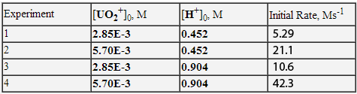
What is the rate law for the reaction?
a. rate = k[UO₂⁺][H⁺] c. rate = k[UO₂⁺]²[H⁺]
b. rate = k[UO₂⁺]²[H⁺]⁴ d. rate = k[UO₂⁺][H⁺]/[U⁴⁺][ UO₂²⁺]

12. Using the reaction coordinate diagram below, determine the activation energy and type of enthalpy change for the reaction.
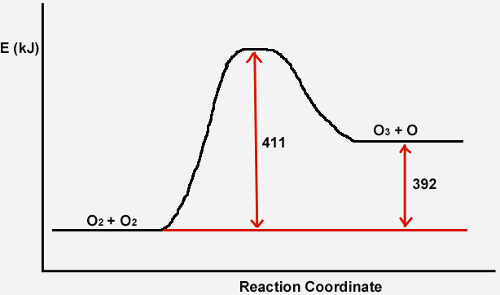

a. E_{a} = 392 kJ, endothermic c. E_{a} = 411 kJ, endothermic
b. E_{a} = 392 kJ, exothermic d. E_{a} = 411 kJ, exothermic

13. The following mechanism is proposed for a reaction:
Step 1: NO₂Cl NO₂ + Cl
Step 2: Cl + NO₂Cl NO₂ + Cl₂

Write the overall reaction: ______________________________________

What is the molecularity of Step 2: _______________________
Give formulas of intermediates (if none, enter “none): ____________
Give formulas of catalysts (if none, enter “none): ___________

14. The reaction coordinate diagram for a reaction and its concentration-time curve are shown for the reaction run at 25 ºC.
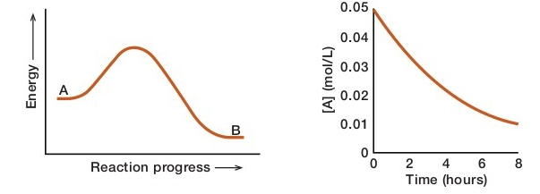
a. draw a curve on the left plot that has a lower activation energy.
b. draw a curve on the right plot for the reaction run if the activation energy were lower. Label it L.
c. draw a curve on the right plot for the reaction run at lower temperature. Label it C.
d. If the energy of the products (B in the left plot) were lower, the reaction rate would be:
faster slower the same

Long Answer Questions: Show Your Work
15. A reaction has the following measured rate constants at two temperatures.
k = 22.0 s⁻¹ at 270 K
k = 54.0 s⁻¹ at 300 K
What is the activation energy?

E_{a} = _________ kJ
16. Consider the system, 2 CH₂Cl₂(g) CH₄(g) + CCl₄(g), which has an equilibrium constant of
K = 2.4. If a system has:

[CH₂Cl₂] = 0.22 M
[CH₄] = 1.64 M
[CCl₄] = 0.58 M

What is the value of Q? ____________________

Then choose what will happen:
(a) the system is at equilibrium
(b) the system is not at equilibrium and will react to form more CH₂Cl₂
(c) the system is not at equilibrium and will react to form more CH₄ and CCl₄

17. The half-life of U-238 is 4.5 x 10⁹ years. When U-238 decays it undergoes a series of reactions to form Pb-207.
²³⁸U ²⁰⁷Pb
If a rock is found that contains 0.384 g U-238 and 0.122 g Pb-207. If we assume that all the Pb-207 originated by decay of the uranium, how old is the rock?
You can assume the molar masses of the isotopes equal their mass numbers.

age = ___________ years
18. What is the conjugate base of H₂PO₄⁻?
(a) H₃PO₄ (b) HPO₄²⁻ (c) 2 HPO₂ (d) PO₄³⁻

19. Write the formulas of Write the formulas of
common strong acids: common strong bases:

20. Calculate the following for a solution that has a pH of 4.68?

[H₃O⁺] = ______________ mol/L

[OH⁻ ] = _______________ mol/L

pOH = ________

21. What is the pH of a 0.00248 M solution of Ba(OH)₂?

What is the pH of a 4.8 x 10⁻⁴ M solution of HNO₃?

What is the pH of a 3.0 M solution of HCl?

Equations and Constants
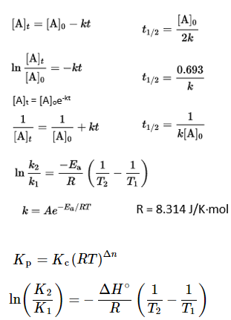
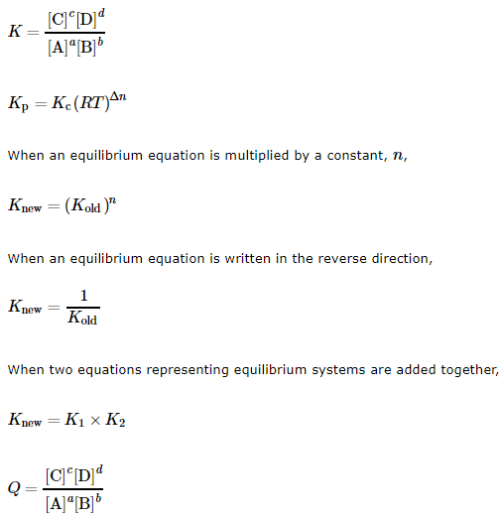
pH = -log[H₃O⁺]
[H₃O⁺] = 10^{-pH}
pOH = -log[OH⁻]
[OH⁻] = 10^{-pOH}
K_{w} = 1.0 x 10⁻¹⁴ at 25 ºC

