Chem 112 – 2020 Practice Exam
Vining

1. Which of the following will create a buffer solution when equal volumes of each solution are mixed? Circle all that apply—there may be more than one correct answer.

(a) 0.20 M HNO₃ + 0.10 M H₂CO₃
(b) 0.20 M HCO₂H + 0.10 M NaHCO₂
(c) 0.20 M HF + 0.20 M CaF₂
(d) 0.10 M HNO₃ + 0.30 M NaCH₃CO₂

2. Which of the following acids has the largest K_{a} value?
H₃AsO₂ H₃AsO₃ H₃AsO₄

3. Which of the following acid-base pairs would be used to create a buffer of pH = 4.62, and which species would be present in higher concentration? Circle the acid-base pair used.

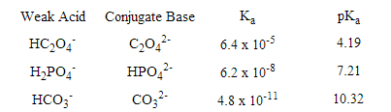

Circle one of these:

The conjugate acid will be in higher concentration than the conjugate base.

The conjugate base will be in higher concentration than the conjugate acid.

4. The value of K_{a} for phenol (a weak acid, C₆H₅OH) is 1.1 × 10⁻¹⁰.

What is the value of K_{b}, for its conjugate base, C₆H₅O⁻? _______________

What is pKa? ____________ In what form will phenol exist at pH = 7: C₆H₅OH or C₆H₅O⁻
5. Write the chemical reaction equation described by the K_{a} value for H₂CO₃.

Write the chemical reaction equation described by the K_{b} value for NaF.

6. Write the net-ionic equation for the acid-base reaction between HNO₂ and ClO⁻:

Write the net-ionic equation for the acid-base reaction between HCl and KOH:

7. What is the pH of a 0.60 M solution of acetic acid, CH₃CO₂H?
Ka = 1.8 x 10⁻⁵

8. Consider the alpha plot below, which is for an acid-base system HA/A⁻.
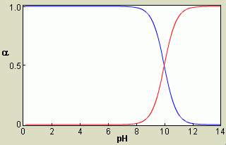

a. At pH = 11, which species is present in greater concentration?
HA or A⁻ or about the same amount of each

b. What is pK_{a} of HA? _____________

c. What is K_{a} of HA? _______________

9. a) What is the pH of a buffer composed of 1.00 L of 0.400 M HCN and 0.700 M CN⁻?
K_{a} = 4.0 x 10⁻¹⁰

10. Consider the titration curve below involving a weak acid (C₂H₇NH⁺) and a weak base (C₂H₇N).
a. Which does this titration represent? Circle it.

weak acid being titrated with NaOH or

weak base being titrated with HCl

b. What is the approximate value of K_{a} for the acid

form (C₂H₇NH⁺) of the studied acid-base pair?

K_{a} = ___________________
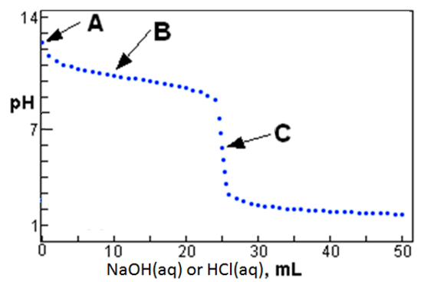

For the questions below, answer with C₂H₇NH⁺, C₂H₇NH, H₃O⁺ and/or OH⁻. More than one is allowed.

c. What acid-base species is/are mainly in solution at point A? ___________________________

d. What acid-base species is/are mainly in solution at point B? ___________________________

e. What acid-base species is/are mainly in solution at point C? ___________________________

11. What mass of NH₄Cl must be added to a 0.380 M solution of NH₃ to make 1.0 L of a buffer of pH = 8.93?
Molar mass NH₄Cl = 53.45 g/mol

__________ g NH₄Cl

12. You have a saturated solution of AgCl that has solid AgCl at the bottom of the solution. Some NaCl solution is added to the AgCl solution. What happens?

a) nothing
b) more AgCl precipitates
c) NaCl precipitates
d) solid AgCl dissolves

13. Will Cu₃(PO₄)₂ be more soluble in pure water, or in water in which Na₃PO₄ has been dissolved?

Cu₃(PO₄)₂(s) 3 Cu²⁺(aq) + 2 PO₄³⁻(aq)

a) pure water b) Na₃PO₄ solution

Is Fe(OH)₂ more soluble in:
a) pure water b) 0.1 M HCl c) 0.1M NaOH

14. Write the equilibrium reaction and the K_{sp} equilibrium expression for dissolution of:
Al₂(CO₃)₃

15. Label any species that are acting as Lewis acids (LA), Lewis bases (LB), Bronsted acids (BA), or Bronsted bases (BB).
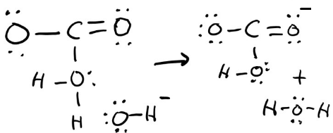

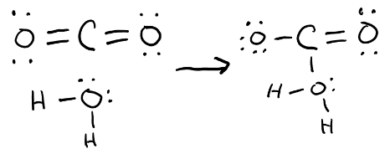

16. What is the solubility of Cd₃(PO₄)₂, in moles per liter? K_{sp} = 2.2 x 10⁻³²

_____________ mol/L

17. What is the solubility of PbBr₂ is a 0.15 M solution of NaBr, in grams per liter?
Molar mass PbBr₂ = 367 g/mol. K_{sp} = 6.6 x 10⁻⁶

_____________ g/L

18. Cu²⁺ forms a complex ion with ammonia:
Cu²⁺(aq) + 4 NH₃(aq) ===== [Cu(NH₃)₄]²⁺(aq) K_{f} = 2.1 x 10¹³

Formation of the complex ion is: highly favored moderately favored not favored

What is the value of K_{d}, the dissociation constant for the complex ion, [Cu(NH₃)₄]²⁺?

K_{d} = _______________

Equations and Constants
Useful Information

pH = -log[H₃O⁺] pOH = -log[OH⁻] K_{w} = 1.0 x 10⁻¹⁴ at 25 ºC
[H₃O⁺] = 10^{-pH} [OH⁻] = 10^{-pOH}
