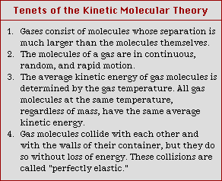
KE = ½ mv² m = mass; v = velocity
Table 10.6: Tenets of the Kinetic Molecular Theory

Root Mean Square Speed:

R = gas constant = 8.314

Effusion: Rate of escape from a small hole:

Boltzmann Distributions: Temperature Changes
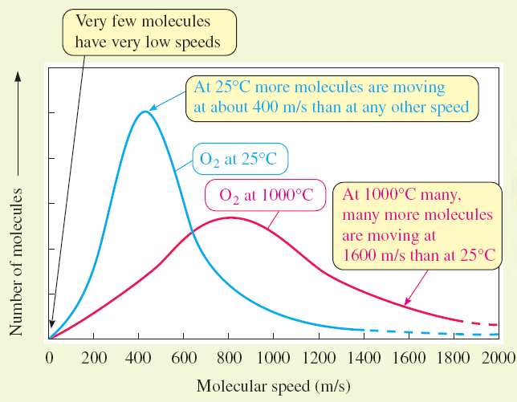

Different Gases
