Name: _________________ Pre-Laboratory Quiz

Section (day and time): _________________

Solubilty Product Determination

- Which of the following correctly represents the products when aqueous NaCl is added to an aqueous solution of silver nitrate?

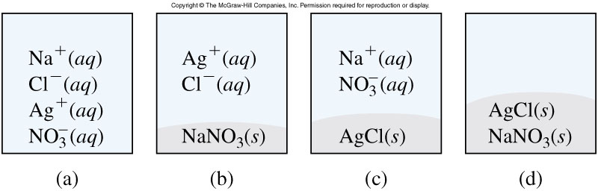

- Write the net ionic equation for the process described in question 1.

- A student needs to determine the concentration of Mg(OH)₂ that is in an unknown solution by titrating a known volume of the unknown solution with HCl. In order to calculate the concentration of Mg(OH)₂ in the unknown solution, the student also needs to know (obtain):

  - the concentration of the HCl
B. the volume of the HCl used for the titration
C. the amount of indicator added to the titration vessel
D. A, B and C
E. A and B
4. The hydroxide ion concentration in a 0.10 M Ca(OH)₂ solution is:
A. 0.10 M
B. 0.05 M
C. 0.20 M

- The solubilty product expression for lead iodide is:

  - K_{sp} = [Pb²⁺][I⁻]
  - K_{sp} = [Pb²⁺][I⁻]²
  - K_{sp} = [Pb²⁺]
[I⁻]²

References: Chang, R., General Chemistry 9th Edition

