DETERMINATION OF THE SOLUBILITY PRODUCT OF GROUPII HYDROXIDES
INTRODUCTION
SOLUBILTY EQUILIBRIA
Many systems in chemistry appear to be static when in fact they are in (dynamic) equilibrium. When a system is in dynamic equilibrium the rate of the forward process is equal to the rate of the reverse process. One of these equilibrium systems is solubility equilibrium. When an ionic salt is placed in water if the salt is soluble then the salt will break apart (dissociate) into ions and the solution will contain hydrated positive ions and hydrated negative ions. An example is the formation of Na⁺ (aq) and Cl⁻ (aq) when NaCl is dissolved in water.
Consulting solubility tables tell us that most hydroxides are insoluble and therefore do not dissociate into ions when in solution. For example the net ionic equation for the reaction between MgCl₂ and KOH is shown below. (Equation 1, Figure 1).
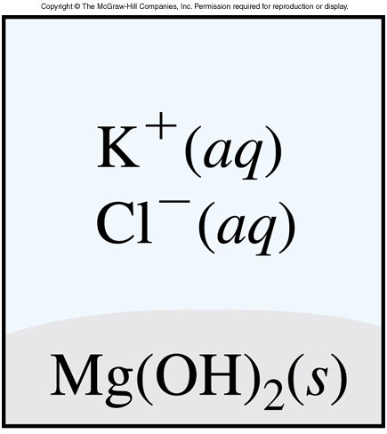
Mg²⁺ (aq) + 2(OH⁻) (aq) Mg(OH)₂ (Equation 1)

Figure (1)

However, even compounds considered insoluble will form a small amount of ions in solution. If a salt is “insoluble” what is really happening is that the equilibrium for the formation of hydrated ions from the reaction between the solid salt and water lies very far to the left (toward the solid). The formation of this small amount of ions and their recombination make up a system in dynamic equilibrium.
The equilibrium constant for this process is called the solubility product, K_{sp}. The equilibrium reaction and equilibrium constant expression for Mg(OH)₂ is shown below. (Note that the Mg(OH)₂ does not appear in the equilibrium expression since it is a solid. Similar equilibrium expressions can be written for other insoluble salts.
Mg(OH)₂ (s) Mg²⁺ (aq) + 2OH⁻ (aq) K_{sp} << 1
K_{sp} = [Mg²⁺][OH_]²

In this experiment you will determine the K_{sp} of three (essentially) insoluble hydroxides by titrating saturated solutions of the hydroxides with HCl.
ACID-BASE TITRATIONS
Titrations are an important method of chemical analysis, and allow us to determine concentrations of unknown solutions. Categories of titrations include redox (oxidation-reduction titrations) and acid-base titrations. This acid-base titration is an example of a neutralization reaction in which hydrogen ions (protons) and hydroxide ions react to produce water. In this experiment you will titrate solutions containing OH⁻ ions (analyte, which you do not know the concentration of). The solutions to be titrated are magnesium hydroxide, Mg(OH)₂; calcium hydroxide, Ca(OH)₂ ; and strontium hydroxide, Sr(OH)₂. The net ionic equation for the reaction between HCl and each of these compounds is

2H⁺ + 2OH⁻ 2H₂O

The titration ends when exactly the right amount of H⁺ ions have been added to react with all of the OH⁻ ions in the solution. This is called the equivalence (end) point of the titration, because at this point, the number of moles of titrant (H⁺ ions) added is exactly the same as the number of moles of analyte (OH⁻ ions) in the sample. The equivalence point is recognized by a change in color of indicator in the solution. In this experiment, the indicator is phenolphthalein which is pink in basic solution (Figure 2, left and colorless in at the end point, Figure 2 , right). At this point the volume of titrant added can be measured and used to determine the concentration of the analyte.

EXPERIMENTAL
Apparatus
50 mL buret
Graduated cylinder
Buret stand with clamp
Erlenmeyer Flasks
Pipets and pipet bulb

Procedure
- Clean all glassware by first washing with detergent and water and then rinsing with distilled water.
USE OF A PIPET
A volumetric pipet is designed to measure the exact volume marked on the pipet volumetric pipets are used extensively in chemical laboratories for accurate transfer of specific volumes of liquids. A pipet will be used to measure the solutions of the saturated solutions of the hydroxides.
To draw solution into the pipet follow the instructions below.
WARNING!! DO NOT DRAW LIQUID INTO PIPET BY MOUTH
- Squeeze the pipet bulb and then place it on the pipet so that it makes an air-tight seal against the mouth of the pipet.
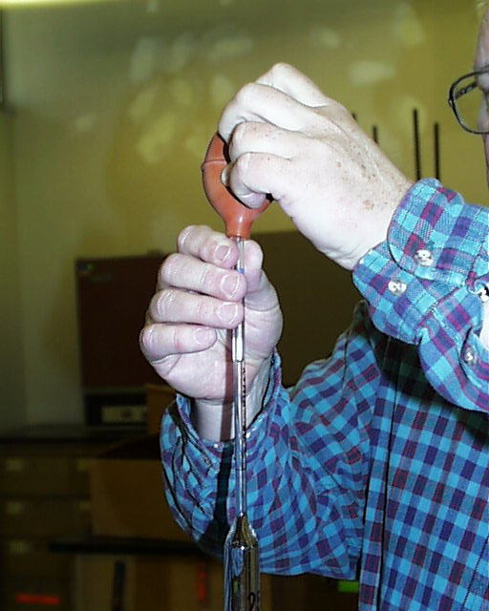

- Place the tip of the pipet into the solution which is to be drawn up, the solution will be pulled into the pipet as the bulb is slowly released. Be sure to keep the tip of the pipet in solution in order to prevent air from being drawn into the pipet.
- Pull the liquid a few cm beyond the calibration mark, remove the bulb and immediately place your finger on the mouth of the pipet.
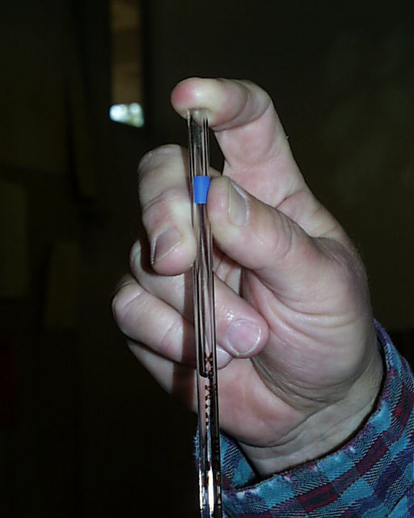

- Move your finger slightly from the mouth of the pipet so that the liquid begins to drain. Immediately stop the flow of liquid by re-sealing the mouth of the pipet with your finger when the bottom of the meniscus of the liquid reaches the calibration mark (shown below).

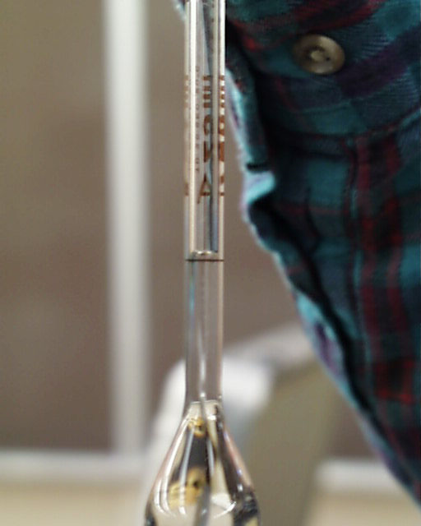
Left: A pipet that has been properly filled. Note also that there should be no air bubbles in the solution.
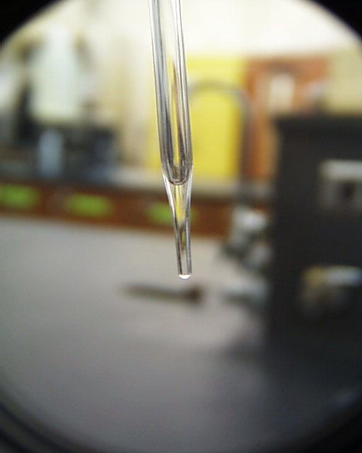
Do NOT attempt to blow out the liquid remaining in the tip of the pipet since the pipet is designed to DELIVER the volume specified.

USE OF A BURET (Note that there is a video posted illustrating the use of a buret.
- Rinse the CLEAN buret with a small amount of the titrant (HCl) solution, be sure the walls and the tip of the buret come into contact with the solution.
- Set up the buret using the stand and clamp.
- Use a buret funnel to fill the buret with the HCl solution provided. Record the initial buret reading.
- Remember not to allow the solution from the buret to drain to below the 50 mL mark!
TITRATIONS (Note that there is a video posted illustrating how to perform titrations)
Magnesium Hydroxide Titration
- Obtain about 80 mL of Mg(OH)₂ solution in a beaker.
- Use a pipet to withdraw 25.00 mL of this solution and place it in an Erlenmeyer flask; add three drops of phenolphthalein indicator and titrate with HCl to a COLORLESS end point. Record the buret reading at the end (equivalence) point.
- This titration should be performed at LEAST in duplicate. Remember to re-fill the buret between titrations if needed and to record initial and final buret readings for EACH titration.
Calcium Hydroxide Titration
- Obtain about 5 mL Ca(OH)₂ solution in a beaker.
- Use a pipet to withdraw 1.00 mL of this solution and place it in an Erlenmeyer flask; add 20 mL of distilled water (can you use need a pipet for this) add three drops of phenolphthalein indicator and titrate with HCl to a COLORLESS end point. Record the buret reading at the end (equivalence) point.
- This titration should be performed at LEAST in duplicate. Remember to re-fill the buret between titrations if needed and to record initial and final buret readings for EACH titration.
Strontium Hydroxide Titration
- Obtain about 5 mL Sr(OH)₂ solution in a beaker.
- Use a pipet to withdraw 1.00 mL of this solution and place it in an Erlenmeyer flask; add three drops of phenolphthalein indicator and titrate with HCl to a COLORLESS end point. Record the buret reading at the end (equivalence) point.
- This titration should be performed at LEAST in duplicate. Remember to re-fill the buret between titrations if needed and to record initial and final buret readings for EACH titration.
Calculations and Data Handling
- Use the data collected and stoichiometry to determine the concentration of OH⁻ ion in each solution. Report an average OH⁻ concentration for each substance.
- Use the (average) [OH⁻] obtained to calculate the solubility product (K_{sp}) for each of the three group II hydroxides analyzed.
Post-Lab questions
- Suggest a possible explanation for the trend in solubility product (K_{sp}) values obtained.

- Considering the trend of the K_{sp} values you obtained, assign the following K_{sp} values to the correct compound.
K_{sp} | Compound
2.55 × 10⁻⁴ | Be(OH)₂
6.92 × 10⁻²² | Ba(OH)₂

- Would you be able to determine the solubility product of barium sulfate using this method? Why or why not?

