Nuclear Fuel Production
Fissile Nuclei: Uranium and Plutonium

²³⁵U and ²³⁹Pu

Uranium
Two isotopes
99.3% ²³⁸U not useful for energy production
0.7% ²³⁵U useful for energy production

For a nuclear reactor: Need 4% ²³⁵U
For a fission bomb: Need 90% ²³⁵U

Reacting the Fuel: Fission Reactions
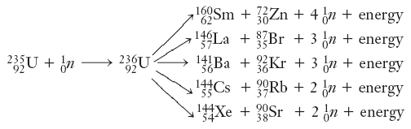
Chain Reactions
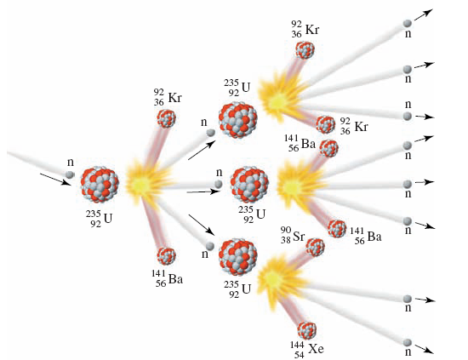
Controlling the Reactions: Control Rods
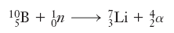
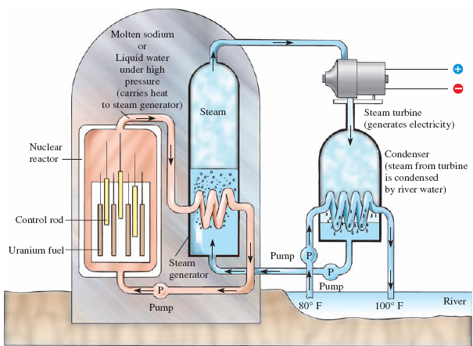

Producing Uranium Fuel
U ore contains small amounts of UO₂ and UO₃.

Step 1. Oxidize UO₂ to UO₃.

Step 2. Solubilize U by reacting with H₂SO₄

UO₃(s) + 2 H⁺(aq) UO₂²⁺(solid salt) + H₂O(l)

UO₂²⁺(solid salt) + 3 SO₄²⁻(aq) UO₂(SO₄)₃⁴⁻(aq)

Key: Uranium is solubilized and is leached out of the rock.

Step 3. More Reactions, eventually to yield UO₃.

2 R₃N + H₂SO₄ (R₃NH)₂SO₄

2 (R₃NH)₂SO₄ + UO₂(SO₄)₃⁴⁻ (R₃NH)₄UO₂(SO₄)₃(aq) + 2 SO₄²⁻(aq)

(R₃NH)₄UO₂(SO₄)₃ + 2(NH₄)₂SO₄ 4 R₃N + (NH₄)₄UO₂(SO₄)₃ + 2 H₂SO₄

2NH₃ + 2UO₂(SO₄)₃⁴⁻(aq) (NH₄)₂U₂O₇(s) + 4 SO₄²⁻(aq)

(NH₄)₂U₂O₇(s) U₃O₈(s) + H₂O(l) + NH₃(g)

U₃O₈ is then reacted to make pure UO₃.

Key: UO₃ formed is pure.

Step 4. Formation of UF₆
UO₃(s) + H₂(g) ====> UO₂(s) + H₂O
UO₂(s) + 4HF(g) ====> UF₄(s) + 2H₂O(l)
UF₄(s) + F₂(g) ====> UF₆(l or g)
Key: UF₆ has a boiling point near 50 ºC.

Step 5. Fuel-Level Enrichment: 4%
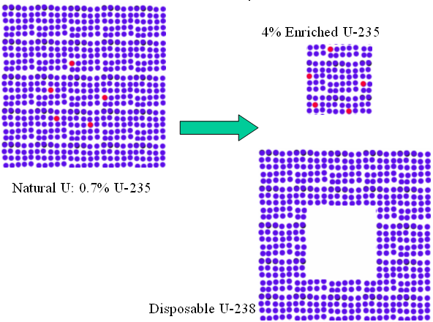

Efficiencies:
diffusion = 1.002/stage
Final Fraction = 0.7 x (1.002)^{#cycles}

gas centrifuge: 1.2/stage
Final Fraction = 0.7 x (1.2)^{#cycles}

Plutonium Fuel:
Made inside Uranium Nuclear Reactors

