Subatomic Particles
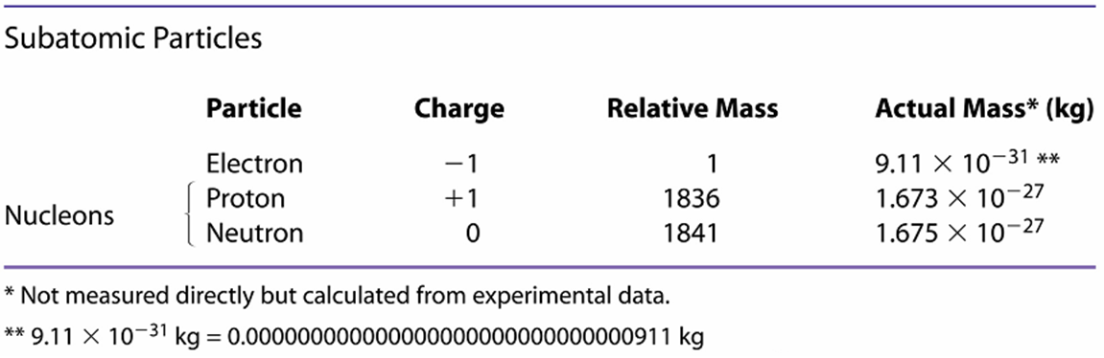

Atomic Structure
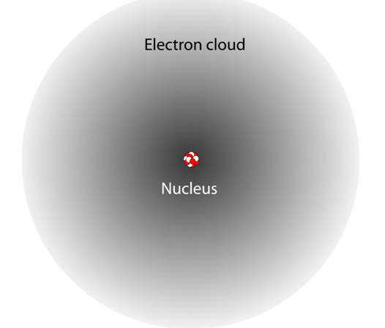 | Rutherford Experiment 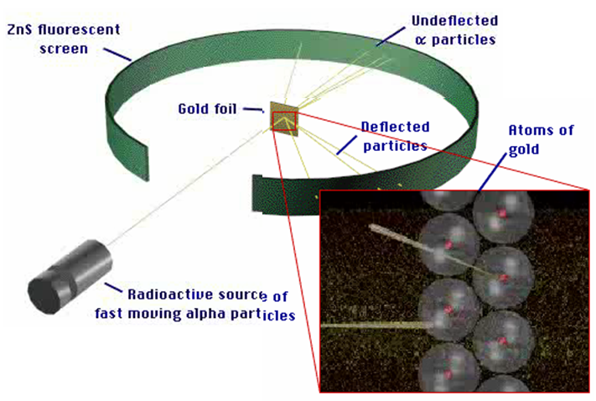

Atom Terminology:
- All atoms of an element have the same atomic number = number of protons
- In a neutral atom (no charge), the number of positively and negatively charged particles must be equal.
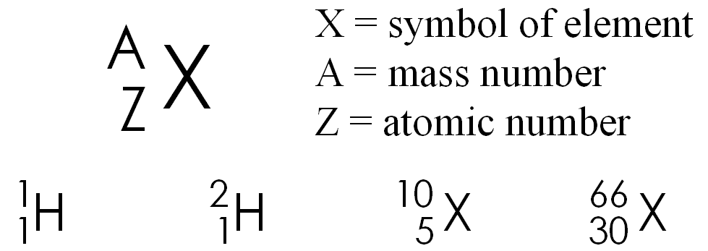
Number protons = number electrons
- The mass number = protons + neutrons
- Isotopes are atoms of an element with the same number of protons but different numbers of neutrons, and different mass

Average Atomic Mass = weighted average of atomic mass of all atoms

Example:
B has 2 isotopes: B-10: mass = 10.0129 amu B-11: mass = 11.0093
abundance = 19.91% abundance = 80.09%
What is the average atomic mass of Boron?

