Important Types of Organic Reactions

A. Combustion Reactions
Reaction with oxygen gas to form CO₂ and H₂O.

C₃H₈(g) + 5 O₂(g) → 3 CO₂(g) + 4 H₂O(l)

B. Substitution Reactions
Exchange of one atom or molecular fragment.

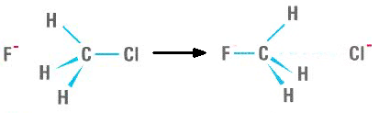

C. Addition Reactions
Addition of two molecules together.

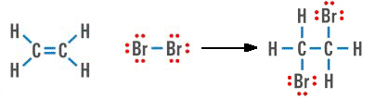

D. Elimination Reactions
Ejection of a small molecule from a larger one.

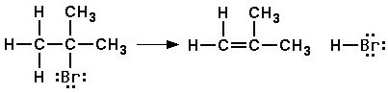

E. Isomerization (Rearrangement) Reactions
Change of shape of a molecule without gain or loss of any atoms.

