Stoichiometry in Solution
Pure Elements and Compounds
Mass → Moles

Moles → Mass

Solutions
Volume → Moles
Moles → Volume

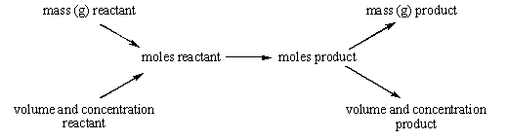

Examples:

1. What is mass of PbCrO₄ produced when 50.0 mL
of a 0.400 M Pb(NO₃)₂ solution is mixed with an
excess of 0.100 M K₂CrO₄?

3. 100 mL of 0.25 M HCl reacts with 100 mL of 0.25 M NH₃. What is the concentration of NH₄Cl in the final solution?

2. Calculate volume (in mL) of 0.715 M HNO₃ needed to
react completely with 6.35 g of CaCO₃ in a gas
forming reaction.

