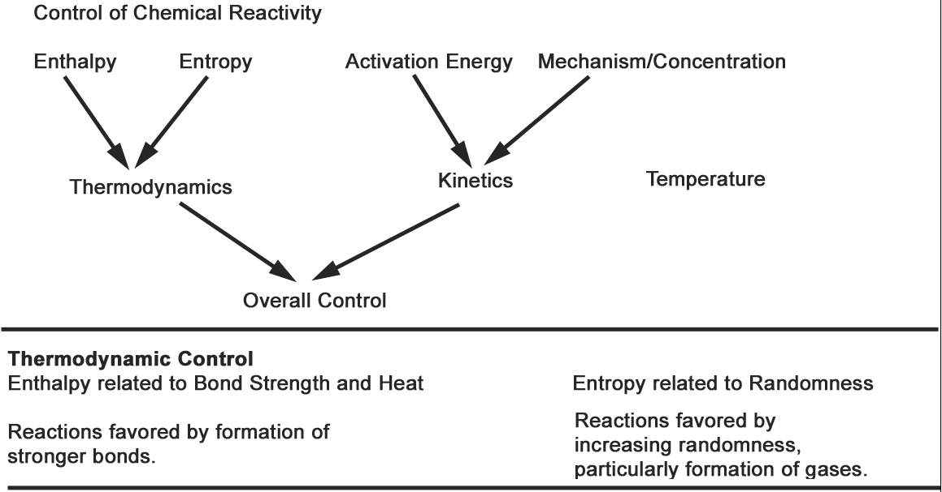

First Law of Thermodynamics: Energy is Conserved: ΔE_{universe} = 0

Energy is neither created or destroyed during chemical or physical changes, but it is transformed from one form to another.

TYPES of ENERGY

Kinetic Potential

Mechanical Gravitational
Thermal Electrostatic
Electrical Chemical
Radiant

Energy Conversion Examples:

1. dropping a rock

2. using a flashlight

3. driving a car up hill
Energy Units:
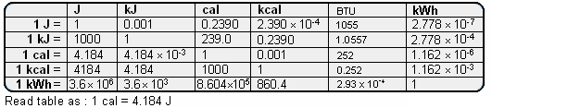

SYSTEMS and SURROUNDINGS

System: The thing under study
Surroundings: Everything else in the universe

Energy transfer between system and surroundings:

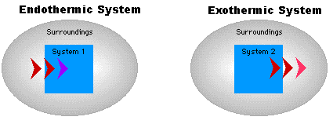
Endo: heat added to system Exo: heat released by system

HEAT: What happens to thermal (heat) energy?

Three possibilities:
- Warms another object
- Causes a change of state
- Is used in an endothermic reaction

Temperature Changes from Heat Exchange
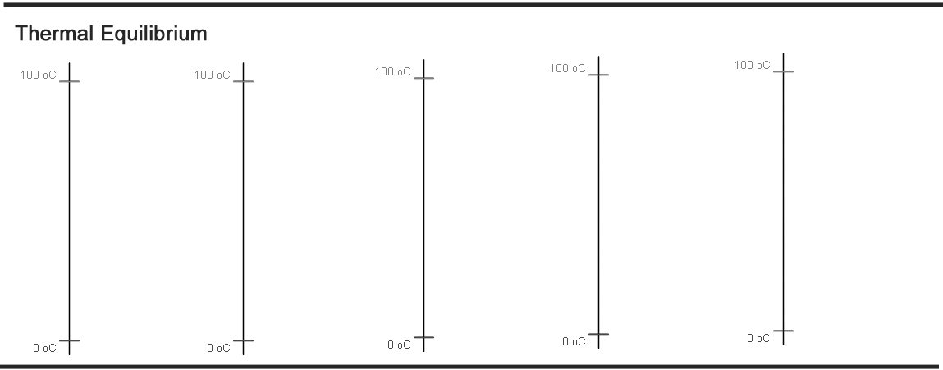

When objects of different temperature meet:
- Warmer object cools
- Cooler object warms
- Thermal energy is transferred
- q_{warmer} = -q_{cooler}

Quantitative: Calculating Heat Exchange: Specific Heat Capacity

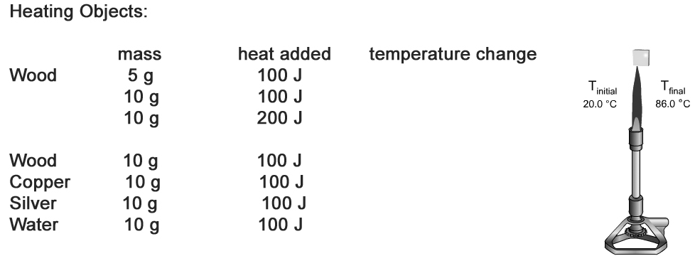
Specific Heat Capacity

Definition: The energy required to heat one gram of a substance by 1 ºC.

Usefulness: #J transferred = S.H. x #g x ΔT

Example: How much energy is used to heat 250 g water from 17 ºC to 100 ºC?

Table of Values
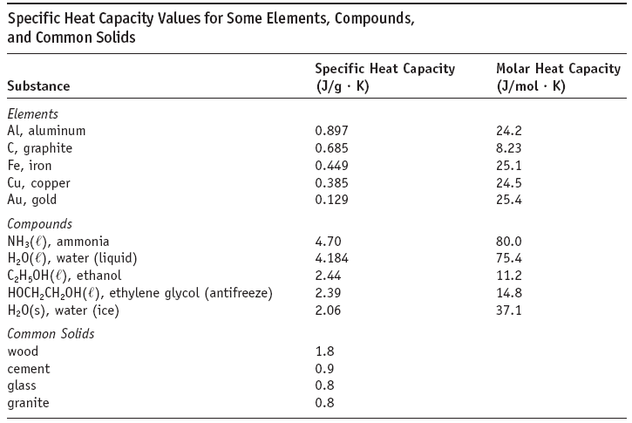

Return to Heat Exchange: What happens to thermal (heat) energy?

When objects of different temperature meet:
- Warmer object cools
- Cooler object warms
- Thermal energy is transferred
- q_{warmer} = -q_{cooler}

specific heat x mass x ΔT = specific heat x mass x ΔT
warmer object cooler object

Explain this:
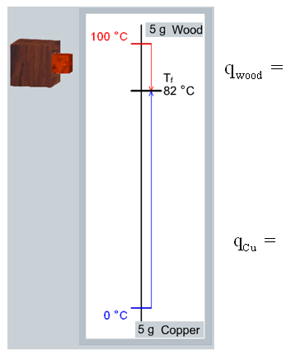

Conceptually Easy Example with Annoying Algebra:

If we mix 250 g H₂O at 95 ºC with 50 g H₂O at 5 ºC, what will the final temperature be?

