Enthalpy Change and Chemical Reactions

ΔH = energy needed to break bonds – energy released forming bonds

Bond strengths: H-H 436 kJ/mol
O=O 498 kJ/mol
O-H 463 kJ/mol

ΔH = [498 + (2 x 436)] – [4 x 436] kJ = -482 kJ

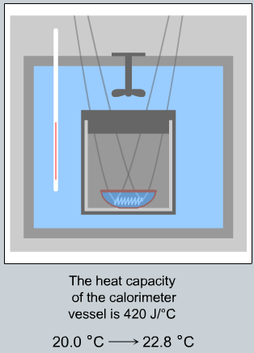
Calorimetry: Measuring ΔH

Run reaction in a way where the amount of heat exchanged
can be measured.

Here: 500 mg H₂N₂ is burned in a calorimeter containing 600 g water.
Temperature change = 20.0 ºC → 22.8 ºC
Calorimeter absorbs 420 J/ºC

Heat generated = heat absorbed by water + heat absorbed by calorimeter

______________________________________________________________________
Hess’s Law

If you can add reactions together, you can add their delta H values:

The trick to using Hess’s
Law is to find a way to add known reactions together to
get the reaction you are interested in. Most often, you need to reverse one or more reactions and multiply them by a constant.
