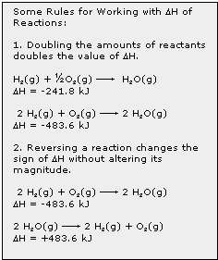
Calculating Heat Production:

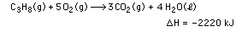
If we burn 0.25 mol propane, heat produced is,

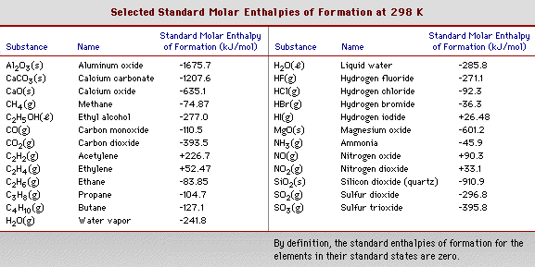

Using Heats of Formation:
Example:

What is ΔH for the reaction

2 CO(g) + O₂(g) → 2 CO₂(g)

= [2 x (-393.5)] – [2 x (-110.5) + 0]
Energy Sources

What percentage of our cost of living does energy account for?

1. 2% 2. 8% 3. 25% 4. 50%

What percentage of our national trade deficit is due to energy?

1. 2% 2. 8% 3. 25% 4. 50%

What percentage of our energy use is due to fossil fuels?

1. 6% 2. 8% 3. 50% 4. 75% 5. 85%

What percentage of our energy use is due to “renewable” energy sources?

1. 6% 2. 8% 3. 50% 4. 75% 5. 85%

Are we in danger of running out of energy sources?

1. yes 2. no

Existing Energy Sources, all in Terawatt-years
Oil and Gas: ~1000
Coal: 5000
Oil Shale 30,000
Uranium 2000 for conventional reactors; 2,000,000 for breeder reactors

Potential Energy Sources
Nuclear Fusion 140,000,000 if we can get it to work
Renewable, yearly:
Wind 2,000
Sunlight 26,000
Biomass 60

