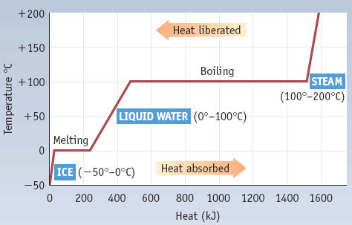
Heating Curve Calculations: Cold ice to hot steam:
Warming ice:

Melting ice:

Warming water:

Boiling water:

Heating steam:

Enthalpy Change and Chemical Reactions

ΔH = energy needed to break bonds – energy released forming bonds

Bond strengths: H-H 436 kJ/mol
O=O 498 kJ/mol
O-H 463 kJ/mol

ΔH = [498 + (2 x 436)] – [4 x 436] kJ = -374 kJ

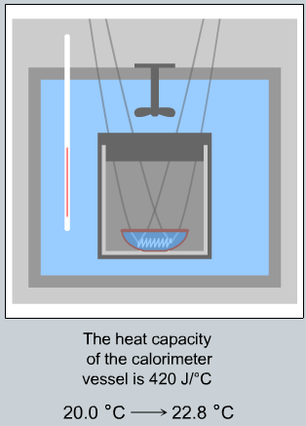
Calorimetry: Measuring ΔH

Run reaction in a way where the amount of heat exchanged
can be measured.

Here: 500 mg H₂N₂ is burned in a calorimeter containing 600 g water.
Temperature change = 20.0 ºC → 22.8 ºC
Calorimeter absorbs 420 J/ºC

Heat generated = heat absorbed by water + heat absorbed by calorimeter

